Question 12.1
Drag and drop the SNMP components from the left onto the descriptions on the right.
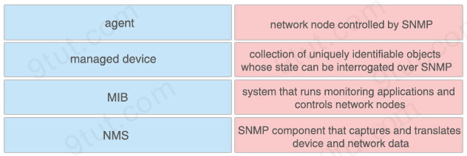

Answer:
+ network node controlled by SNMP: managed device
+ collection of uniquely identifiable objects whose state can be interrogated over SNMP: MIB
+ system that runs monitoring applications and controls network nodes: NMS
+ SNMP component that captures and translates device and network data: agent
Explanation
The SNMP agent is the software component within the managed device that maintains the data for the device and reports these data, as needed, to managing systems. The agent and MIB reside on the routing device (router, access server, or switch). To enable the SNMP agent on a Cisco routing device, you must define the relationship between the manager and the agent.
Question 12.2
Refer to the exhibit.
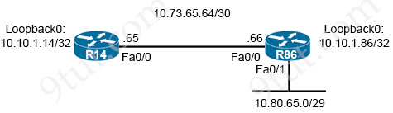
An engineer must configure a floating static route on an external EIGRP network. The destination subnet is the /29 on the LAN interface of R86. Which command must be executed on R14?
A. ip route 10.80.65.0 255.255.248.0 10.73.65.66 1
B. ip route 10.80.65.0 255.255.255.240 fa0/1 89
C. ip route 10.80.65.0 255.255.255.248 10.73.65.66 171
D. ip route 10.73.65.66 0.0.0.224 10.80.65.0 255

Answer: C
Question 12.3
Drag and drop the statements about device management from the left onto the corresponding types on the right.
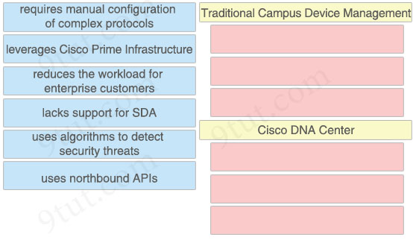

Answer:
Traditional Campus Device Management:
+ requires manual configuration of complex protocols
+ leverages Cisco Prime Infrastructure
+ lacks support for SDA
Cisco DNA Center:
+ reduces the workload for enterprise customers
+ uses algorithms to detect security threats
+ uses northbound APIs
Explanation
One of the example of traditional network management, Cisco Prime Infrastructure (PI) Management has been used to manage enterprise networks.
Reference: https://ipcisco.com/lesson/traditional-network-management-versus-cisco-dna-center/
Question 12.4
A network engineer is implementing a corporate SSID for WPA3-Personal security with a PSK. Which encryption cipher must be configured?
A. GCMP128
B. GCMP256
C. CCMP256
D. CCMP128

Answer: D
Explanation
WPA3 mandates the adoption of Protected Management Frames, which help guard against eavesdropping and forging. It also standardizes the 128-bit cryptographic suite and disallows obsolete security protocols. WPA3-Enterprise has optional 192-bit security encryption and a 48-bit IV for heightened protection of sensitive corporate, financial and governmental data. WPA3-Personal uses CCMP-128 and AES-128.
Reference: https://www.techtarget.com/searchnetworking/feature/Wireless-encryption-basics-Understanding-WEP-WPA-and-WPA2
Configuring WPA3 (GUI)
…
Step 8 – In the WPA2+WPA3 Parameters section, choose WPA3 as the Policy.
If you choose Personal, Encryption Cipher is limited to CCMP128(AES) and Authentication Key Management is in the PSK format.
Step 9
Chose the Encryption Cipher from the following options:
CCMP128(AES)
CCMP256 (not available for Personal security type)
GCMP128 (not available for Personal security type)
GCMP256 (not available for Personal security type)
Reference: https://www.cisco.com/c/en/us/td/docs/wireless/controller/8-10/config-guide/b_cg810/wlan_security.html
Question 12.5
What is the functionality of the Cisco DNA Center?
A. data center network policy controller
B. software-defined controller for automation of devices and services
C. console server that permits secure access to all network devices
D. IP address pool distribution scheduler

Answer: B
Question 12.6
Which IP header field is changed by a Cisco device when QoS marking is enabled?
A. Header Checksum
B. Type of Service
C. DSCP
D. ECN

Answer: B
Question 12.7
Refer to the exhibit.
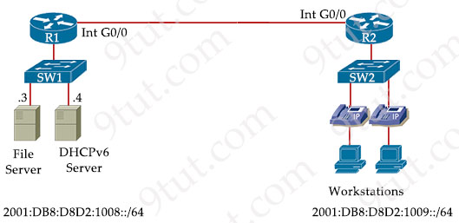
An IPv6 address must be obtained automatically on the LAN interface on R1. Which command must be implemented to accomplish the task?
A. ipv6 address 2001:db8:d8d2:1008:4358:23:1390::/64
B. ipv6 address fe80::/10
C. ipv6 address dhcp
D. ipv6 address autoconfig

Answer: C
Explanation
In fact there are two correct answers for this question, which are “ipv6 address autoconfig” and “ipv6 address dhcp”. The first command can work with or without a DHCPv6 server. The second command “ipv6 address dhcp” is correct too as we can see there is a DHCPv6 on the same LAN so this command works well in this question. As the author of this question put a DHCPv6 server in the topology so maybe answer “ipv6 address dhcp” is the better choice!
Note: The “ipv6 address autoconfig” command causes the device to perform IPv6 stateless address auto-configuration to discover prefixes on the link and then to add the EUI-64 based addresses to the interface.
Question 12.8
Refer to the exhibit.
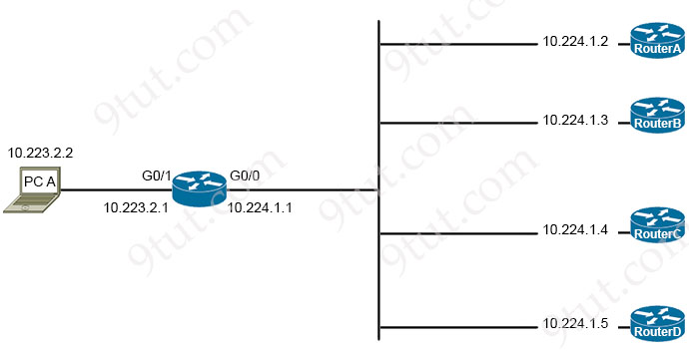
Router-Y#show ip route

Codes: L - local, C - connected, S - static, R - RIP, M - mobile, B - BGP
D - EIGRP, EX - EIGRP external, O - OSPF, IA - OSPF inter area
N1 - OSPF NSSA external type 1, N2 - OSPF NSSA external type 2
E1 - OSPF external type 1, E2 - OSPF external type 2
i - IS-IS, su - IS-IS summary, L1 - IS-IS level-1, L2 - IS-IS level-2
ia - IS-IS inter area, * - candidate default, U - per-user static route
o - ODR, P - periodic downloaded static route, H - NHRP, l - LISP
+ - replicated route, % - next hop override, p - overrides from PfR

Gateway of last resort is not set

10.0.0.0/8 is variably subnetted
B 10.0.0.0/8 [1/0] via 10.224.1.2
B 10.27.150.224/27 [20/0] via 10.224.1.3, 1w6d
S 10.128.0.0/9 [1/0] via 10.224.1.3
B 10.224.0.0/11 [20/0] via 10.224.1.5, 5d18h
B 10.224.0.0/15 [20/0] via 10.224.1.4, 5d18h
C 10.223.0.0/24 is directly connected, GigabitEthernet0/1
C 10.224.0.0/24 is directly connected, GigabitEthernet0/0
B 10.226.34.0/24 [20/0] via 10.224.1.5, 5d18h
PC A is communicating with another device at IP address 10.227.225.255. Through which router does router Y route the traffic?
A. router A
B. router B
C. router C
D. router D

Answer: D
Explanation
The destination IP address 10.227.225.255 belongs to 10.224.0.0/11 subnet and this is the longest prefix subnet so router Y will send traffic from PC A to 10.224.1.5, which is router D.
Question 12.9
What are two protocols within the IPsec suite? (Choose two)
A. 3DES
B. AH
C. ESP
D. TLS
E. AES

Answer: B C
Explanation
IPsec is a suite of protocols widely used to secure connections over the internet. The three main protocols comprising IPsec are: Authentication Header (AH), Encapsulating Security Payload (ESP), and Internet Key Exchange (IKE).
Reference: https://www.twingate.com/blog/ipsec/
Question 12.10
Drag and drop the IPv6 address type characteristics from the left to the right.
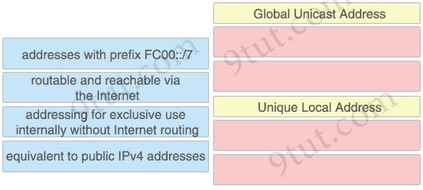

Answer:
Global Unicast Address
+ routable and reachable via the Internet
+ equivalent to public IPv4 addresses
Unique Local Address
+ addresses with prefix FC00::/7
+ addressing for exclusive use internally without Internet routing
Explanation
A IPv6 Unique Local Address is an IPv6 address in the block FC00::/7. It is the approximate IPv6 counterpart of the IPv4 private address. It is not routable on the global Internet.
Note: In the past, Site-local addresses (FEC0::/10) are equivalent to private IP addresses in IPv4 but now they are deprecated.
Question 12.11
What are two benefits of private IPv4 addressing? (Choose two)
A. reuses addresses at multiple sites
B. provides external internet network connectivity
C. conserves globally unique address space
D. propagates routing information to WAN links
E. provides unlimited address ranges

Answer: A C
Question 12.12
Refer to the exhibit.
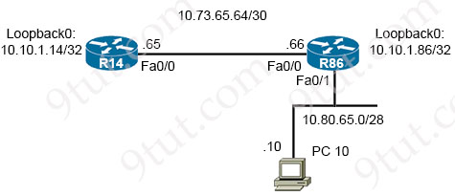
Router R14 is in the process of being configured. Which configuration must be used to establish a host route to PC 10?
A. ip route 10.80.65.10 255.255.255.254 10.80.65.1
B. ip route 10.73.65.66 0.0.0.255 10.80.65.10
C. ip route 10.80.65.10 255.255.255.255 10.73.65.66
D. ip route 10.73.65.65 255.0.0.0 10.80.65.10

Answer: C
Explanation
A host route is an IPv4 address with a 32-bit mask (255.255.255.255).
Question 12.13
Refer to the exhibit.
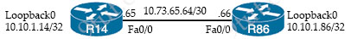
A static route must be configured on R86 to forward traffic for the 172.16.34.0/29 network, which resides on R14. Which command must be used to fulfill the request?
A. ip route 172.16.34.0 255.255.255.248 10.73.65.65
B. ip route 172.16.34.0 255.255.255.224 10.73.65.66
C. ip route 10.73.65.65 255.255.255.248 172.16.34.0
D. ip route 172.16.34.0 0.0.0.7 10.73.65.64

Answer: A
Question 12.14
Refer to the exhibit.
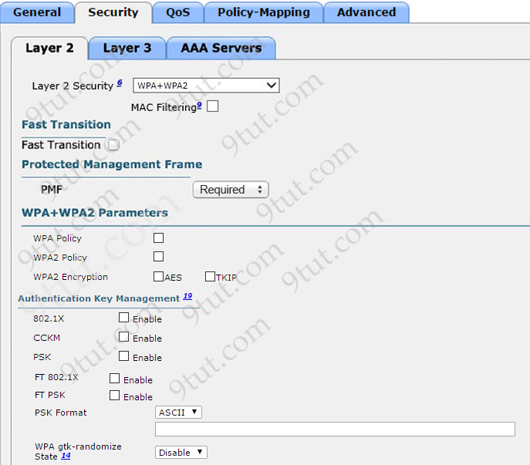
The network engineer is configuring a new WLAN and is told to use a setup password for authentication instead of the RADIUS servers. Which additional set of tasks must the engineer perform to complete the configuration?
A. Disable PMF
Enable PSK
Enable 802.1x
B. Select WPA Policy
Select WPA2 Policy
Enable FT PSK
C. Select WPA2 Policy
Disable PMF
Enable PSK
D. Select WPA Policy
Enable CCKM
Enable PSK

Answer: C
Explanation
Answer A is not correct as we can not enable “PSK” and “802.1x” at the same time.
Answer B is not correct as we can only choose either “WPA Policy” or WPA2 Policy”.
Answer D is not correct as we can not enable “CCKM” and “PSK” at the same time.
We tested answer C successfully and we can configure a password for authentication with either “WPA Policy” or “WPA2 Policy”:
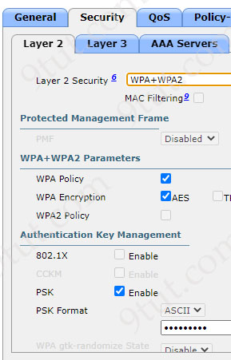 | 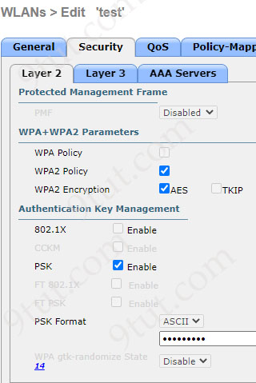
Question 12.15
Refer to the exhibit.
SW1#show run
Building configuration...
!
hostname SW1
!
ip domain-name test
!
username CCNA privilege 1 password 0 ciscol23
!
interface FastEthernet0/1
switchport access vlan 10
!
interface Vlan10
ip address 192.168.1.2 255.255.255.0
!
line vty 0 4
login local
transport input telnet
line vty 5 15
login local
transport input telnet

SW1#show crypto key mypubkey rsa
% Key pair was generated at: 0:1:23 UTC Mar 1 2021
Key name: SW1.test
An engineer is updating the management access configuration of switch SW1 to allow secured, encrypted remote configuration. Which two commands or command sequences must the engineer apply to the switch? (Choose two)
A. SW1(config)#line vty 0 15
SW1(config-line)#transport input ssh
B. SW1(config)# crypto key generate rsa
C. SW1(config)# interface f0/1
SW1(config-if)# switch port mode trunk
D. SW1(config)#enable secret ccnaTest123
E. SW1(config)# username NEW secret R3mote123

Answer: A D
Explanation
“encrypted remote configuration” -> configure SSH.
On VTY lines we configured “login local” command which means that authentication uses locally configured credentials using the “username … secret …” command or “username … password …” command. In this question we already had the latter so we don’t need to configure the former -> Answer E is not correct.
From the “show crypto key mypubkey rsa”, “Key pair was generated” we learned that the command “crypto key generate rsa” has been issued to create the key -> Answer B is not correct.
One interesting of SSH is we need to configure an “enable secret” password or we cannot login to the device. We tested it with IOU Web IOSv15.4 with the configuration above and see this result:
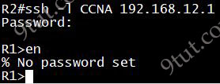
We also created the “NEW” username with command “username NEW secret R3mote123” and received the same result:
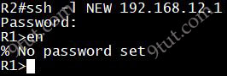
-> Answer D is correct.
Question 12.16
Refer to the exhibit.
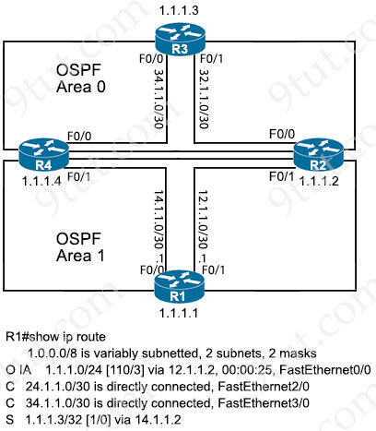
Which two values does router R1 use to identify valid routes for the R3 loopback address 1.1.1.3/32? (Choose two)
A. lowest cost to reach the next hop
B. lowest administrative distance
C. lowest metric
D. highest metric
E. highest administrative distance

Answer: B C
Explanation
It seems there are two versions of this question. If this question has the answer “longest prefix match” then please choose it (instead of “lowest metric” answer).
Question 12.17
Refer to the exhibit.
[
{"switch": "3750", "port": e2},
{"router": "2951", "port": e20},
{"switch": "3750", "port": e23}
]
What is represented by the word “switch” in line 2 of the JSON schema?
A. object
B. key
C. value
D. array

Answer: B
Explanation
JSON uses curly braces {} to hold objects and square brackets [] to hold arrays.
Question 12.18
Refer to the exhibit.
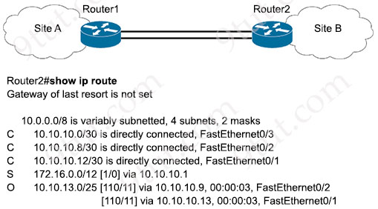
User traffic originating within site B is failing to reach an application hosted on IP address 192.168.0.10, which is located within site A. What is determined by the routing table?
A. The traffic to 192.168.0.10 requires a static route to be configured in router1
B. The lack of a default route prevents delivery of the traffic
C. The default gateway for site B is configured incorrectly.
D. The traffic is blocked by an implicit deny in an ACL on router2.

Answer: B
Explanation
There is no route destined to network 192.168.0.0 so we need this route or the default route.
Question 12.19
Which cable type must be used to interconnect one switch using 1000 BASE-SX GBIC modules and another switch using 1000 BASE-SX SFP modules?
A. LC to LC
B. LC to SC
C. SC to SC
D. SC to ST

Answer: B
Explanation
GBIC and SFP are both hot-swappable input/output devices that plug into a physical port or a slot. GBIC is commonly used with Gigabit Ethernet and Fibre Channel. But its applications are not limited to these two types. There is also Fast Ethernet (FE) GBIC, BIDI GBIC, CWDM GBIC, DWDM GBIC, etc. Generally, GBIC is with the SC connector.
SFP came into existence later than GBIC. SFP transceivers are designed to support SONET (Synchronous Optical Network), Gigabit Ethernet, Fibre Channel, and other communications standards. It is usually with LC connector. SFP is also known as mini-GBIC because it has the same functionality as GBIC but in a smaller form factor.
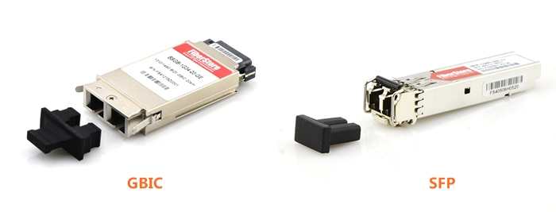-> In summary, GBIC uses SC connector while SFP uses LC connector. Therefore in this question, to connect GBIC to SFP we need LC to SC cable type.
Question 12.20
Drag and drop the virtualization concepts from the left onto the matching statements on the right.
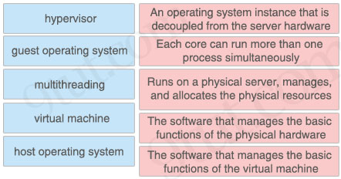

Answer:
+ An operating system instance that is decoupled from the server hardware: virtual machine
+ Each core can run more than one process simultaneously: multithreading
+ Runs on a physical server, manages, and allocates the physical resources: hypervisor
+ The software that manages the basic functions of the physical hardware: host operating system
+ The software that manages the basic functions of the virtual machine: guest operating system
Explanation
Surely answer 2 (Each core can run more than one process simultaneously: multithreading) and answer 3 (Runs on a physical server, manages, and allocates the physical resources: hypervisor) are correct so we only have three matches left.
A virtual machine (VM) is an operating system (OS) or application environment installed on software that imitates dedicated hardware.
Reference: https://www.techtarget.com/searchitoperations/definition/virtual-machine-VM
The definition of “Operating system” is:
“An operating system (OS) is a software that manages computer hardware and software resources …”
Reference: https://www.studysmarter.co.uk/explanations/computer-science/computer-systems/operating-systems/
And in our question there are two options “the software that manages …” so they should be matched for two types of OS.
There are only 2 matches of “guest operating system” and “host operating system” so let’s find out the differences between them. The comparison below is taken from this link (https://www.sangfor.com/glossary/cloud-and-infrastructure/what-is-host-operating-system):
Host Operating Systems vs Guest Operating Systems
While both host operating systems and guest operating use the same resources, they function independently from one another. Guest operating systems differ from the host operating system in several ways:
+ The host operating system is software installed on a computer system that communicates with the underlying hardware. While a guest OS is software that is installed in a virtual machine.
+ The host operating system executes directly on the hardware while a guest operating system executes on a virtual machine.
Therefore the best matches should be “The software that manages the basic functions of the virtual machine: guest operating system” and “An operating system instance that is decoupled from the server hardware: host operating system“.
Question 12.21
Which channel-group mode must be configured when multiple distribution switch interfaces connected to a WLC are bundled?
A. channel-group mode active
B. channel-group mode on
C. channel-group mode desirable
D. channel-group mode passive

Answer: B
Explanation
Cisco Wireless LAN Controller Configuration Guide, Release 7.4
Link aggregation (LAG) is a partial implementation of the 802.3ad port aggregation standard. It bundles all of the controller’s distribution system ports into a single 802.3ad port channel. This reduces the number of IP addresses required to configure the ports on your controller. When LAG is enabled, the system dynamically manages port redundancy and load balances access points transparently to the user.
LAG requires the EtherChannel to be configured for ‘mode on’ on both the controller and the Catalyst switch.
Reference: https://www.cisco.com/c/en/us/td/docs/wireless/controller/7-4/configuration/guides/consolidated/b_cg74_CONSOLIDATED/b_cg74_CONSOLIDATED_chapter_010100001.html
Question 12.22
Refer to the exhibit.
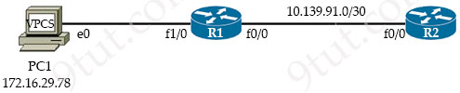
R1#
!
interface Loopback0
ip address 10.1.1.1 255.255.255.255
!
interface FastEthernet0/0
ip address 10.139.91.1 255.255.255.252
ip virtual—reassembly in
!
interface FastEthernet1/0
ip address 172.16.29.1 255.255.255.0
ip virtual-reassembly in
!
router eigrp 100
network 10.1.1.1 0.0.0.0
network 10.139.91.0 0.0.0.3
!
--output suppressed--
An engineer must translate the PC1 IP address to 10.199.77.100 and permit PC1 to ping the loopback 0 interface on router R2. Which configuration must be used?
Option A  R1#  !  interface FastEthernet0/0  ip nat outside  !  interface FastEthernet1/0  ip nat inside  !  ip nat inside source static 172.16.29.78 10.199.77.100  R2  ip route 10.199.77.100 255.255.255.255 10.139.91.1 | Option B  R1#  !  interface FastEthernet0/0  ip nat inside  !  interface FastEthernet1/0  ip nat outside  !  ip nat inside source static 10.199.77.100 172.16.29.78  R2  ip route 10.199.77.100 255.255.255.255 10.139.91.1
Option C  R1#  !  interface FastEthernet0/0  ip nat outside  !  interface FastEthernet1/0  ip nat inside  !  ip nat inside source static 172.16.29.78 10.199.77.100  R2  ip route 172.16.29.78 255.255.255.255 10.139.91.1 | Option D  R1#  !  interface FastEthernet0/0  ip nat outside  !  interface FastEthernet1/0  ip nat inside  !  ip nat inside source static 172.16.29.78 10.199.77.100  R2  ip route 172.16.29.78 255.255.255.255 10.139.91.1
A. Option A
B. Option B
C. Option C
D. Option D

Answer: A
Explanation
PC1 can ping the loopback 0 interface on R2 so R2 must know how to route to 10.199.77.100. In this question R2 uses a static route so it should be:
R2:
ip route 10.199.77.100 255.255.255.255 10.139.91.1 -> Only Option A and Option B are correct.
Interface F1/0 on R1 must be “ip nat inside” and F0/0 must be “ip nat outside” -> Only Option A is correct.
Question 12.23
Drag and drop the TCP or UDP details from the left onto their corresponding protocols on the right.
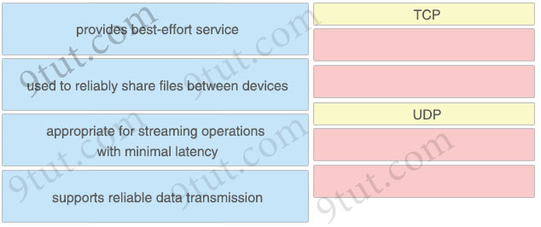

Answer:
TCP
+ used to reliably share files between devices
+ supports reliable data transmission
UDP
+ provides best-effort service
+ appropriate for streaming operations with minimal latency
Question 12.24
A network engineer must configure an interface with IP address 10.10.10.145 and a subnet mask equivalent to 11111111.11111111.11111111.11111000. Which subnet mask must the engineer use?
A. /27
B. /28
C. /29
D. /30

Answer: C
Question 12.25
Which two server types support domain name to IP address resolution? (Choose two)
A. ESX host
B. web
C. resolver
D. authoritative
E. file transfer

Answer: C D
Explanation
All DNS servers fall into one of four categories: Recursive resolvers, root nameservers, TLD nameservers, and authoritative nameservers.
Question 12.26
Refer to the exhibit.
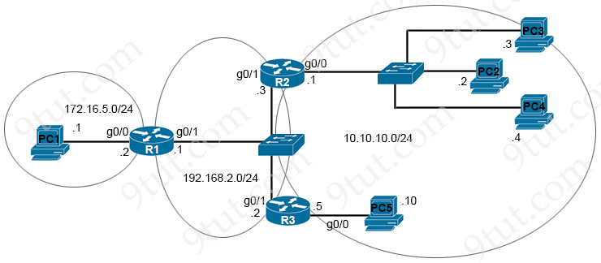
The router R1 is in the process of being configured. Routers R2 and R3 are configured correctly for the new environment. Which two commands must be configured on R1 for PC1 to communicate to all PCs on the 10.10.10.0/24 network? (Choose two)
A. ip route 10.10.10.8 255.255.255.248 g0/1
B. ip route 10.10.10.10 255.255.255.255 g0/1
C. ip route 10.10.10.0 255.255.255.248 192.168.2.2
D. ip route 10.10.10.0 255.255.255.0 192.168.2.3
E. ip route 10.10.10.10 255.255.255.255 192.168.2.2

Answer: D E
Question 12.27
Which switching feature removes unused MAC addresses from the MAC address table, which allows new MAC addresses to be added?
A. MAC move
B. MAC address aging
C. dynamic MAC address learning
D. MAC address auto purge

Answer: B
Question 12.28
Which two northbound APIs are found in a software-defined network? (Choose two)
A. SOAP
B. OpFlex
C. REST
D. NETCONF
E. OpenFlow

Answer: A C
Explanation
SDN northbound APIs are usually RESTful APIs used to communicate between the SDN Controller and the services and applications running over the network. Another northbound API is Simple Object Access Protocol (SOAP).
Question 12.29
What uses HTTP messages to transfer data to applications residing on different hosts?
A. REST
B. OpenStack
C. OpFlex
D. OpenFlow

Answer: A
Explanation
REST (Representational State Transfer) describes a type of API that allows applications to sit on different hosts, using HTTP messages to transfer data over the API.
Question 12.30
Refer to the exhibit.
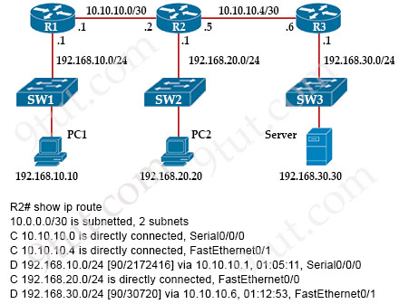
What is the next-hop IP address for R2 so that PC2 reaches the application server via EIGRP?
A. 10.10.10.5
B. 192.168.20.1
C. 10.10.10.6
D. 192.168.30.1

Answer: C
Question 12.31
Drag and drop the configuration management terms from the left onto the descriptions on the right. Not all terms are used.
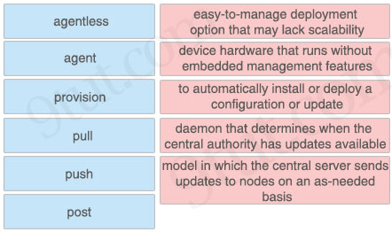

Answer:
+ easy-to-manage deployment option that may lack scalability: agent
+ device hardware that runs without embedded management features: agentless
+ to automatically install or deploy a configuration or update: pull
+ daemon that determines when the central authority has updates available: provision
+ model in which the central server sends updates to nodes on an as-needed basis: push
Question 12.32
A switch is forwarding a frame out of all interfaces except the interface that received the frame. What is the technical term for this process?
A. CDP
B. multicast
C. flooding
D. ARP

Answer: C
Question 12.33
What is a characteristic of RSA?
A. It uses preshared keys for encryption
B. It is an asymmetric encryption algorithm
C. It requires both sides to have identical keys for encryption
D. It is a symmetric decryption algorithm.

Answer: B
Explanation
RSA is a public-key encryption algorithm that uses an asymmetric encryption algorithm to encrypt data. Asymmetric encryption uses a key pair that is mathematically linked to encrypt and decrypt data. A private and public key are created, with the public key being accessible to anyone and the private key being a secret known only by the key pair creator. With RSA, either the private or public key can encrypt the data, while the other key decrypts it. This is one of the reasons RSA is the most used asymmetric encryption algorithm.
Question 12.34
Refer to the exhibit.
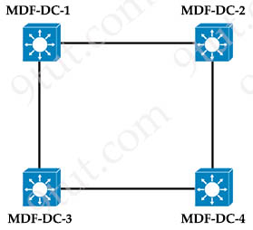
All interfaces are in the same VLAN. All switches are configured with the default STP priorities. During the STP elections, which switch becomes the root bridge?
A. MDF-DC-3: 08:0E:18:1A:3C:9D
B. MDF-DC-4: 08:E0:19:A1:B3:19
C. MDF-DC-2: 08:0E:18:22:05:97
D. MDF-DC-1: 08:E0:43:78:24:50

Answer: A
Question 12.35
Which advantage does the network assurance capability of Cisco DNA Center provide over traditional campus management?
A. Cisco DNA Center leverages YANG and NETCONF to assess the status of fabric and nonfabric devices, and traditional campus management uses CLI exclusively
B. Cisco DNA Center correlates information from different management protocols to obtain insights, and traditional campus management requires manual analysis
C. Cisco DNA Center automatically compares security postures among network devices, and traditional campus management needs manual comparisons
D. Cisco DNA Center handles management tasks at the controller to reduce the load on infrastructure devices, and traditional campus management uses the data backbone.

Answer: B
Explanation
DNA Center uses many management protocols to provide a single pane of glass for all devices.
Question 12.36
Which signal frequency appears 60 times per minute?
A. 1 Hz signal
B. 1 GHz signal
C. 60 Hz signal
D. 60 GHz signal

Answer: A
Explanation
“60 times per minutes” means “60 times per 60 seconds”.
Frequency of 1 Hz implies to 1 complete vibration per second. This means, 60 complete vibrations in 60 second, or, in 1 minute.
Question 12.37
Which port type does a lightweight AP use to connect to the wired network when it is configured in local mode?
A. access
B. trunk
C. EtherChannel
D. LAG

Answer: A
Explanation
Trunk mode is only required when using FlexConnect mode or when using an autonomous AP that has multiple SSIDs assigned to multiple VLANs.
Question 12.38
Refer to the exhibit.
Cat9300-1# show interface g1/0/1 switchport
Name: Gi1/0/1
Switchport: Enabled
Administrative Mode: trunk
Operational Mode: trunk
Administrative Trunking Encapsulation: dot1q
Operational Trunking Encapsulation: dot1q
Negotiation of Trunking: On
Access Mode VLAN: 1 (default)
Trunking Native Mode VLAN: 321 (VLAN0321)
Administrative Native VLAN tagging: enabled
Trunking VLANs Enabled: 100,200,300
Pruning VLANs Enabled: 2-1001
A network administrator configures an interface on a new switch so that it connects to interface Gi1/0/1 on switch Cat9300-1. Which configuration must be applied to the new interface?
A. switchport trunk encapsulation dot1q
switchport trunk native vlan 321
switchport trunk allowed vlan 100-300
B. switchport mode dynamic desirable
switchport trunk native vlan 321
switchport trunk allowed vlan 100,200,300
C. switchport nonegotiate
switchport access vlan 321
switchport trunk allowed vlan except 2-1001
D. switchport mode trunk
switchport trunk native vlan 321
switchport trunk allowed vlan 100,200,300

Answer: D
Explanation
“Administrative mode” is what’s configured on the switch port (via the “switchport mode access/trunk/dynamic auto/dynamic desirable” command) while “Operational mode” is the actual status (result of interaction with the device connected to the port), like trunk with ISL or 802.1Q encapsulation.
In this question, the “Administrative mode” is “trunk” so it was configured with the “switchport mode trunk” command. And “Trunking VLANs Enabled: 100,200,300” means it only allows three VLANs 100, 200 and 300 so we have to use the “switchport trunk allowed vlan 100,200,300” on the new switch interface.
Question 12.39
What is the function of a controller in a software-defined network?
A. multicast replication at the hardware level
B. setting packet-handling policies
C. forwarding packets
D. fragmenting and reassembling packets

Answer: B
Question 12.40
A client experiences slow throughput from a server that is directly connected to the core switch in a data center. A network engineer finds minimal latency on connections to the server, but data transfers are unreliable, and the output of the show interfaces counters errors command shows a high FCS-Err count on the interface that is connected to the server. What is the cause of the throughput issue?
A. high bandwidth usage
B. a physical cable fault
C. a speed mismatch
D. a cable that is too long

Answer: B
Explanation
Frame Check Sequence Errors: The number of frame check sequence errors during the latest collection interval. Frame check sequence (FCS) errors indicate that frames of data are being corrupted during transmission. FCS error count is the number of frames that were transmitted or received with a bad checksum (CRC value) in the Ethernet frame.
Reference: https://www.ibm.com/docs/en/omegamon-networks/5.5.0?topic=attributes-kn3-osa-express5s-ports-errors
FCS is a checksum error, this is highly likely to be a physical layer issue.
Answer D is not correct as the latency on long cable is high.
Question 12.41
Which component controls and distributes physical resources for each virtual machine?
A. physical enclosure
B. OS
C. hypervisor
D. CPU

Answer: C
Explanation
The hypervisor abstracts and isolates the VMs and their programs from the underlying server hardware, enabling a more efficient use of physical resources, simpler maintenance and operations, and reduced costs.
Reference: https://www.nutanix.com/info/hypervisor
Question 12.42
Which command enables HTTP access to the Cisco WLC?
A. config network secureweb enable
B. config certificate generate webadmin
C. config network webmode enable
D. config network telnet enable

Answer: C
Explanation
Enable or disable web mode by entering this command:
config network webmode {enable | disable}
This command allows users to access the controller GUI using “http://ip-address.” The default value is disabled. Web mode is not a secure connection.
Reference: https://www.cisco.com/c/en/us/td/docs/wireless/controller/8-0/configuration-guide/b_cg80/b_cg80_chapter_011.html
Note: The command “config network secureweb enable” enables HTTPS access to the WLC.
Question 12.43
A network engineer must migrate a router loopback interface to the IPv6 address space. If the current IPv4 address of the interface is 10.54.73.1/32, and the engineer configures IPv6 address 0:0:0:0:0:ffff:a36:4901, which prefix length must be used?
A. /64
B. /96
C. /124
D. /128

Answer: D
Explanation
IPv4 Mapped Address – 0:0:0:0:0:FFFF::/96
The format for IPv4 Mapped address has the first 80 bits set to zeros, followed by the next 16 bits set to all ones and finally, the last 32 bits written in dotted decimal appended to then end forming 128 bit IPv6 address.
An example of an IPv4 Class A address of 12.155.166.101 would look like this in IPv4 Mapped address 0000:0000:0000:0000:0000:FFFF:12.155.166.101 or ::FFFF:12.155.166.101 in IPv6’s short form.
But in this question we are migrate a /32 IP address to IPv6 so the IPv6 address should be /128.
We can see a similar conversion at this link: https://docs.aws.amazon.com/waf/latest/developerguide/classic-web-acl-ip-conditions.html
– To specify the IPv4 address 192.0.2.44, enter 192.0.2.44/32.
– To specify the IPv6 address 0:0:0:0:0:ffff:c000:22c, enter 0:0:0:0:0:ffff:c000:22c/128.
Question 12.44
What is the primary purpose of a console port on a Cisco WLC?
A. out-of-band management via an IP transport
B. out-of-band management via an asynchronous transport
C. in-band management via an asynchronous transport
D. in-band management via an IP transport

Answer: B
Explanation
The console port is used for out-of-band management, system recovery, and early boot operations.
Reference: https://www.geeksforgeeks.org/physical-infrastructure-connections-of-wlan-components/
Console port does not use IP. It is an asynchronous transport.
Question 12.45
Drag and drop the AAA features from the left onto the corresponding AAA security services on the right. Not all options are used
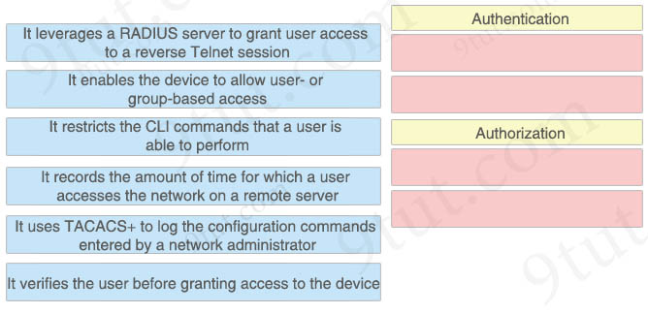

Answer:
Authentication
+ It leverages a RADIUS server to grant user access to a reverse Telnet session
+ It verifies the user before granting access to the device
Authorization
+ It enables the device to allow user- or group-based access
+ It restricts the CLI commands that a user is able to perform
Explanation
The two unused options “It records the amount of time for which a user accesses the network on a remote server” and “It uses TACACS+ to log the configuration commands entered by a network administrator” are Accounting features.
To use RADIUS server to allow a reverse Telnet session we have to use such command “aaa authentication login reverse-access group radius”. Therefore the option “It leverages a RADIUS server to grant user access to a reverse Telnet session” should belong to Authentication, not Authorization.
Note: Reverse telnet allows you to telnet to a device then from that device connect to the console of another device.
Question 12.46
What does the implementation of a first-hop redundancy protocol protect against on a network?
A. BGP neighbor flapping
B. default gateway failure
C. root-bridge loss
D. spanning-tree loops

Answer: B
Question 12.47
Refer to the exhibit.
Codes: L - local, C - connected, S - static, R - RIP, M - mobile, B - BGP
D - EIGRP, EX - EIGRP external, O - OSPF, IA - OSPF inter area
N1 - OSPF NSSA external type 1, N2 - OSPF NSSA external type 2
E1 - OSPF external type 1, E2 - OSPF external type 2
i - IS-IS, su - IS-IS summary, L1 - IS-IS level-1, L2 - IS-IS level-2
ia - IS-IS inter area, * - candidate default, U - per-user static route
o - ODR, P - periodic downloaded static route, H - NHRP, l - LISP
+ - replicated route, % - next hop override, p - overrides from PfR
Gateway of last resort is 0.0.0.0 to network 0.0.0.0
S* 0.0.0.0/0 is directly connected, Null0
10.0.0.0/8 is variably subnetted, 6 subnets, 2 masks
C 10.0.12.0/24 is directly connected, GigabitEthernet0/1
L 10.0.12.1/32 is directly connected, GigabitEthernet0/1
C 10.0.13.0/24 is directly connected, GigabitEthernet0/2
L 10.0.13.1/32 is directly connected, GigabitEthernet0/2
C 10.0.14.0/24 is directly connected, GigabitEthernet0/3
L 10.0.14.1/32 is directly connected, GigabitEthernet0/3
D 192.168.0.0/16 [90/130816] via 10.0.13.3, 00:10:09, GigabitEthernet0/2
O 192.168.0.0/23 [110/2] via 10.0.14.4, 00:00:46, GigabitEthernet0/3
S 192.168.0.0/24 [100/0] via 10.0.12.2
Which interface is chosen to forward traffic to the host at 192.168.0.55?
A. GigabitEthernet0/1
B. Null0
C. GigabitEthernet0/3
D. GigabitEthernet0/2

Answer: A
Explanation
The best match for the destination host 192.168.0.55 is the last statement in the output. But the exit interface of this entry has been hidden so we have to figure it out. We only know the next hop IP address is 10.0.12.2.
We see only Gi0/1 belongs to this subnet from the entry “C 10.0.12.0/24 is directly connected, GigabitEthernet0/1″ so the best answer is Gi0/1.
Question 12.48
Refer to the exhibit.
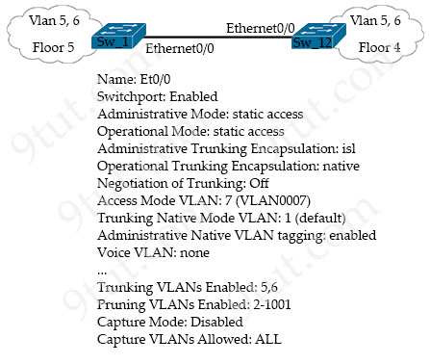
SW_1 and SW_12 represent two companies that are merging. They use separate network vendors. The VLANs on both sides have been migrated to share IP subnets. Which command sequence must be issued on both sides to join the two companies and pass all VLANs between the companies?
A. switchport mode trunk
switchport trunk encapsulation dot1q
B. switchport mode trunk
switchport trunk allowed vlan all
switchport dot1q ethertype 0800
C. switchport mode dynamic desirable
switchport trunk allowed vlan all
switchport trunk native vlan 7
D. switchport dynamic auto
switchport nonegotiate

Answer: A
Explanation
From the output above, we learn that one of the switch is using ISL trunking protocol which is Cisco proprietary so we must change it to 802.1Q trunking protocol to match with the other switch via the command “switchport trunk encapsulation dot1q”.
Question 12.49
A Cisco engineer notices that two OSPF neighbors are connected using a crossover Ethernet cable. The neighbors are taking too long to become fully adjacent. Which command must be issued under the interface configuration on each router to reduce the time required for the adjacency to reach the FULL state?
A. ip ospf priority 0
B. ip ospf network broadcast
C. ip ospf dead-interval 40
D. ip ospf network point-to-point

Answer: D
Explanation
OSPF detects neighbors by means of Hello packets. Maybe the reason for “The neighbors are taking too long to become fully adjacent” is hello packets are not sent frequently.
With OSPF priority of 0, the OSPF router becomes ineligible for being the DR/BDR on that segment so they cannot reach the FULL state. They will be in DROTHER state -> Answer A is not correct.
The default network type of two OSPF neighbors connected using an Ethernet cable is broadcast already -> Answer B is not correct.
Changing the Dead Interval does not automatically change the Hello Interval -> Answer C is not correct.
Set the network type to “point-to-point”, the OSPF routers will not elect DR/BDR and the routers directly transition to the FULL state once they establish adjacency. If we use the “show ip ospf neighbor” command for point-to-point network, we will see something like this:
Router#sh ip ospf neighbor

Neighbor ID Pri State Dead Time Address Interface
2.2.2.2 0 FULL/- 00:00:37 10.1.1.2 GigabitEthernet0/0
-> Answer D is correct.
Question 12.50
Refer to the exhibit.
{
"Test_Questions" : [
"Automation",
"Configuration",
],
"Test__Exam_Level" : [
"CCNA",
"CCNP",
],
"Test_Response" : [
"Correct",
"Incorrect",
],
}
How many objects, keys, and JSON list values are present?
A. three objects, three keys, and two JSON list values
B. one object, three keys, and two JSON list values
C. three objects, two keys, and three JSON list values
D. one object, three keys, and three JSON list values

Answer: D
Explanation
JSON uses curly braces {} to hold objects and square brackets [] to hold arrays. Therefore in this question there is only one object.
We are not sure what is a “list” value. But if “list” is “array” then there are three of them in this questions.
Question 12.51
What is a benefit of a point-to-point leased line?
A. full-mesh capability
B. flexibility of design
C. low cost
D. simplicity of configuration

Answer: D
Explanation
Point-to-point lines are usually leased from a service provider and are called leased lines…
The advantages of leased lines include
Simplicity: Point-to-point communication links require minimal expertise to install and maintain.
Reference: https://www.ciscopress.com/articles/article.asp?p=2202411&seqNum=7
Question 12.52
What are two differences between WPA2 and WPA3 wireless security? (Choose two)
A. WPA3 uses SAE for stronger protection than WPA2, which uses AES
B. WPA2 uses 128-bit key encryption, and WPA3 supports 128-bit and 192-bit key encryption
C. WPA3 uses AES for stronger protection than WPA2, which uses SAE
D. WPA3 uses AES for stronger protection than WPA2, which uses TKIP
E. WPA2 uses 192-bit key encryption, and WPA3 requires 256-bit key encryption

Answer: A B
Explanation
WPA3 provides improvements to the general Wi-Fi encryption, thanks to Simultaneous Authentication of Equals (SAE) replacing the Pre-Shared Key (PSK) authentication method used in prior WPA versions -> Answer C and answer D are not correct.
Reference: https://www.networkworld.com/article/3316567/what-is-wpa3-wi-fi-security-protocol-strengthens-connections.html
Most WPA2 implementations use 128-bit AES encryption keys. In WPA3, longer key sizes – the equivalent of 192-bit security – are mandated only for WPA3-Enterprise -> Answer E is not correct.
WPA3-Enterprise supports 128-bit Advanced Encryption Standard Counter Mode with Cipher Block Chaining Message Authentication (AES-CCMP 128) as the minimum requirement. It also offers an optional mode using 192-bit encryption.
Question 12.53
Refer to the exhibit.
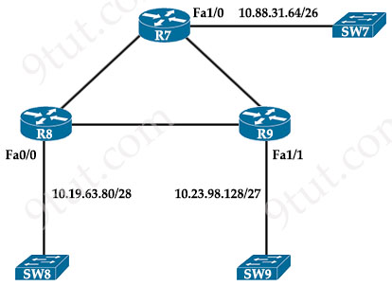
Each router must be configured with the last usable IP address in the subnet. Which configuration fulfills this requirement?
Option A  R7#  interface FastEthernet1/0  ip address 10.88.31.126 255.255.255.192  R8#  interface FastEthernet0/0  ip address 10.19.63.95 255.255.255.192  R9#  interface FastEthernet1/1  ip address 10.23.98.159 255.255.255.248 | Option B  R7#  interface FastEthernet1/0  ip address 10.88.31.126 255.255.255.240  R8#  interface FastEthernet0/0  ip address 10.19.63.94 255.255.255.192  R9#  interface FastEthernet1/1  ip address 10.23.98.158 255.255.255.248
Option C  R7#  interface FastEthernet1/0  ip address 10.88.31.127 255.255.255.240  R8#  interface FastEthernet0/0  ip address 10.19.63.95 255.255.255.192  R9#  interface FastEthernet1/1  ip address 10.23.98.159 255.255.255.248 | Option D  R7#  interface FastEthernet1/0  ip address 10.88.31.127 255.255.255.192  R8#  interface FastEthernet0/0  ip address 10.19.63.95 255.255.255.240  R9#  interface FastEthernet1/1  ip address 10.23.98.159 255.255.255.224
A. Option A
B. Option B
C. Option C
D. Option D

Answer: B (?)
Explanation
On R7 subnet 10.88.31.64/26
Increment: 64
Network address: 10.88.31.64
Broadcast address: 10.88.31.127
-> Last usable IP address: 10.88.31.126
On R8 subnet 10.19.63.80/28
Increment: 16
Network address: 10.19.63.80
Broadcast address: 10.19.63.95
-> Last usable IP address: 10.19.63.94
On R9 subnet 10.23.98.128/27
Increment: 32
Network address: 10.23.98.128
Broadcast address: 10.23.98.159
-> Last usable IP address: 10.23.98.158
In this question only Option B has correct last usable IP addresses but their subnet masks are not correct. For example on R7 the subnet mask should be /26 = 255.255.255.192 (not 255.255.255.240 like in Option B). Maybe they are typos but it is still the best choice.
Question 12.54
Refer to the exhibit.
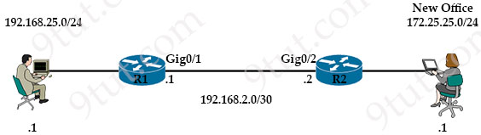
A network engineer is updating the configuration on router R1 to connect a new branch office to the company network. R2 has been configured correctly. Which command must the engineer configure so that devices at the new site communicate with the main office?
A. ip route 172.25.25.1 255.255.255.255 g0/2
B. ip route 172.25.25.0 255.255.255.0 192.168.2.1
C. ip route 172.25.25.1 255.255.255.255 g0/1
D. ip route 172.25.25.0 255.255.255.0 192.168.2.2

Answer: D
Question 12.55
Which two transport layer protocols carry syslog messages? (Choose two)
A. TCP
B. UDP
C. ARP
D. RTP
E. IP

Answer: A B
Explanation
In case of logging significant events, the syslog messages needs to be transported over a reliable channel for it to be stored safely in a server. Usually syslog messages are transported using UDP protocol to the server which is not reliable. This calls for the need for a reliable transport protocol like TCP to transfer the messages to the syslog server.
Reference: https://support.citrix.com/article/CTX205824/how-to-enable-syslog-over-tcp-in-adc
Question 12.56
Refer to the exhibit.
Gateway of last resort is 172.16.2.2 to network 0.0.0.0

10.0.0.0/8 is variably subnetted, 3 subnets, 3 masks
10.10.100.0/26 is directly connected, GigabitEthernet0/0/6
C 10.10.10.0/24 is directly connected, GigabitEthernet0/0/0
L 10.10.10.3/32 is directly connected, GigabitEthernet0/0/0
172.16.0.0/16 is variably subnetted, 3 subnets, 2 masks
S 172.16.1.33/32 is directly connected, GigabitEthernet0/0/1
C 172.16.2.0/23 is directly connected, GigabitEthernet0/0/1
L 172.16.2.1/32 is directly connected, GigabitEthernet0/0/1
S* 0.0.0.0/0 [1/0] via 172.16.2.2
A packet sourced from 10.10.10.32 is destined for the Internet. What is the administrative distance for the destination route?
A. 0
B. 1
C. 2
D. 32

Answer: B
Explanation
There is a trick in this question. It says the “source”, not the destination of the packet is 10.10.10.32 but this information is not useful for finding the destination route. This packet is destined for the Internet (with unknown destination) so it will match the default static route, which is the last entry “S* 0.0.0.0/0 [1/0] via 172.16.2.2”. This entry has the Administrative Distance of 1.
Question 12.57
When is the PUT method used within HTTP?
A. to update a DNS server
B. when a read-only operation is required
C. to display a web site
D. when a nonidempotent operation is needed

Answer: A
Explanation
PUT is similar to POST in that it can create resources, but it does so when there is a defined URL wherein PUT replaces the entire resource if it exists or creates new if it does not exist.
Question 12.58
What describes a northbound REST API for SDN?
A. network-element-facing interface for the control and data planes
B. application-facing interface for GET, POST, PUT, and DELETE methods
C. network-element-facing interface for GET, POST, PUT, and DELETE methods
D. application-facing interface for SNMP GET requests

Answer: B
Question 12.59
Refer to the exhibit.
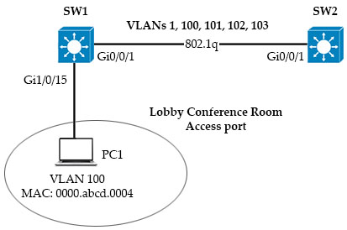
SW1 supports connectivity for a lobby conference room and must be secured. The engineer must limit the connectivity from PC1 to the SW1 and SW2 network. The MAC addresses allowed must be limited to two. Which configuration secures the conference room connectivity?
A. interface gi1/0/15
switchport port-security
switchport port-security mac-address 0000.abcd.0004 vlan 100
B. interface gi1/0/15
switchport port-security mac-address 0000.abcd.0004 vlan 100
C. interface gi1/0/15
switchport port-security mac-address 0000.abcd.0004 vlan 100
interface switchport secure-mac limit 2
D. interface gi1/0/15
switchport port-security
switchport port-security maximum 2

Answer: D
Question 12.60
Refer to the exhibit.
R1# show ip route
Codes: C — connected, S — static, I — IGRP, R - RIP, M - mobile, B — BGP
D — EIGRP, EX - EIGRP external, O — OSPF, IA — OSPF inter area
N1 — OSPF NSSA external type 1, N2 - OSPF NSSA external type 2
E1 - OSPF external type 1, E2 — OSPF external type 2, E — EGP
i — IS-IS, L1 - IS-IS level-1, L2 — IS-IS level-2, * — candidate default
U - per-user static route, o — ODR
Gateway of last resort is not set
C 172.16.0.0/16 is directly connected, Loopback0
172.16.0/16 is variably subnetted, 4 subnets, 2 masks
O 172.16.1.3/3 [110/100] via 192.168.7.40, 00:39:08, Serial0
C 172.16.1.0/24 is directly connected, Serial0
O 172.16.1.184/29 [110/5] via 192.168.7.35, 00:39:08, Serial0
O 172.16.3.0/24 [110/10] via 192.168.7.4, 00:39:08, GigabitEthernet 0/0
D 172.16.1.0/28 [90/10] via 192.168.7.7, 00:39:08, GigabitEthernet 0/0
Load-balanced traffic is coming in from the WAN destined to a host at 172.16.1.190. Which next-hop is used by the router to forward the request?
A. 192.168.7.4
B. 192.168.7.7
C. 192.168.7.35
D. 192.168.7.40

Answer: C
Question 12.61
Refer to the exhibit.
R1#show ip ospf interface g0/0/0
GigabitEthernet0/0/0 is up, line protocol is up
Internet address is 192.168.1.2/24, Area 0
Process ID 1, Router ID 192.168.1.2, Network Type POINT-TO-POINT, Cost: 1
Transmit Delay is 1 sec, State POINT-TO-POINT,
Timer intervals configured, Hello 15, Dead 40, Wait 40, Retransmit 5
Hello due in 00:00:08
Index 1/1, flood queue length 0
Next 0x0(0) /0x0(0)
Last flood scan length is 1, maximum is 1
Last flood scan time is 0 msec, maximum is 0 msec
Suppress hello for 0 neighbor(s)

R2#show ip ospf interface g0/0/0
GigabitEthernet0/0/0 is up, line protocol is up
Internet address is 192.168.1.1/24, Area 0
Process ID 1, Router ID 10.1.1.1, Network Type POINT-TO-POINT, Cost: 1
Transmit Delay is 1 sec, State POINT-TO-POINT,
Timer intervals configured, Hello 15, Dead 45, Wait 15, Retransmit 5
Hello due in 00:00:11
Index 1/1, flood queue length 0
Next 0x0(0)/0x0(0)
Last flood scan length is 1, maximum is 1
Last flood scan time is 0 msec, maximum is 0 msec
Suppress hello for 0 neighbor(s)
The network engineer is configuring router R2 as a replacement router on the network. After the initial configuration is applied it is determined that R2 failed to show R1 as a neighbor. Which configuration must be applied to R2 to complete the OSPF configuration and enable it to establish the neighbor relationship with R1?
Option A  R2(config)#interface g0/0/0  R2(config-if)#ip ospf hello-interval 10 | Option B  R2(config)#router ospf 1  R2(config-router)#router-id 192.168.1.2
Option C  R2(config)#router ospf 1  R2(config-router)#network 192.168.1.0 255.255.255.0 area 2 | Option D  R2(config)#interface g0/0/0  R2(config-if)#ip ospf dead-interval 40
A. Option A
B. Option B
C. Option C
D. Option D

Answer: D
Explanation
In order to become OSPF neighbor, the following values must be matched on both routers:
+ Area ID
+ Authentication
+ Hello and Dead Intervals
+ Stub area Flag
+ MTU Size
In this question we see the Dead intervals are mismatched so we must correct it on one end.
Question 12.62
Refer to the exhibit.
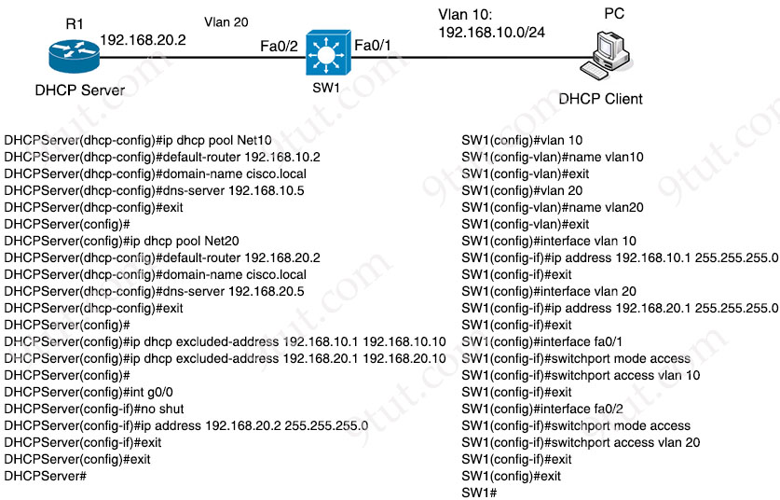
The DHCP server is configured with a DHCP pool for each of the subnets represented. Which command must be configured on switch SW1 to allow DHCP clients on VLAN 10 to receive dynamic IP addresses from the DHCP server?
A. SW1(config-if)#ip helper-address 192.168.10.2
B. SW1(config-if)#ip helper-address 192.168.20.1
C. SW1(config-if)#ip helper-address 192.168.20.2
D. SW1(config-if)#ip helper-address 192.168.10.1

Answer: C
Question 12.63
Drag and drop the DNS lookup commands from the left onto the functions on the right.
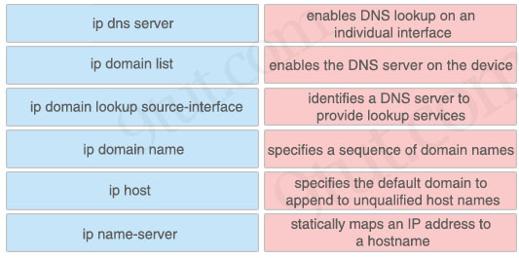

Answer:
+ enables DNS lookup on an individual interface: ip domain lookup source-interface
+ enables the DNS server on the device: ip dns server
+ identifies a DNS server to provide lookup services: ip name-server
+ specifies a sequence of domain names: ip domain list
+ specifies the default domain to append to unqualified host names: ip domain name
+ statically maps an IP address to a hostname: ip host
Explanation
The command “ip domain-lookup” enables DNS-based host name-to-address translation. This command is enabled by default.
The ip domain name defines a list of default domain names to complete unqualified hostnames. The ip domain list command is similar to the ip domain name command, except that with the ip domain list command you can define a list of domains, each to be tried in turn until the system finds a match.
The ip host defines a static hostname-to-address mapping in the hostname cache. For example: Device(config)# ip host cisco-rtp 192.168.0.148
Reference: https://www.cisco.com/c/en/us/td/docs/ios-xml/ios/ipaddr_dns/configuration/15-mt/dns-15-mt-book/dns-config-dns.html
Question 12.64
Drag and drop the TCP or UDP details from the left onto their corresponding protocols on the right.
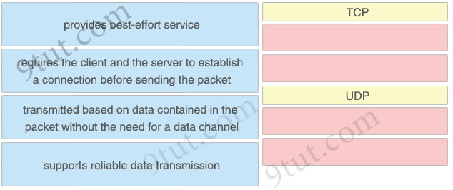

Answer:
TCP
+ requires the client and the server to establish a connection before sending the packet
+ supports reliable data transmission
UDP
+ provides best-effort service
+ transmitted based on data contained in the packet without the need for a data channel
Question 12.65
Refer to the exhibit.
hostname CPE
service password-encryption
ip domain name ccna.cisco.com
ip name-server 198.51.100.210

crypto key generate rsa modulus 1024

username admin privilege 15 secret S0m3s3cr3t

line vty 0 4
transport input ssh
login local
An engineer executed the script and added commands that were not necessary for SSH and now must remove the commands. Which two commands must be executed to correct the configuration? (Choose two)
A. no ip domain name ccna.cisco.com
B. no login local
C. no ip name-server 198.51.100.210
D. no service password-encryption
E. no hostname CPE

Answer: C D
Explanation
In order to configure SSH we need to configure ip domain name first. Then allow SSH with the “transport input ssh” and ask the device to use the local username and password with “login local” command.
We don’t need the “service password-encryption” as “secret” password is always encrypted.
Note: The “login local” command means that authentication uses locally configured credentials using the “username … secret …” command.
Question 12.66
Refer to the exhibit.
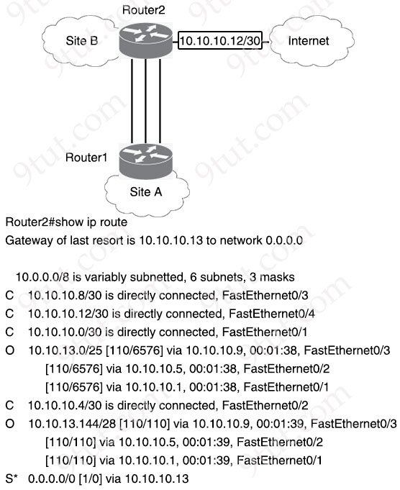
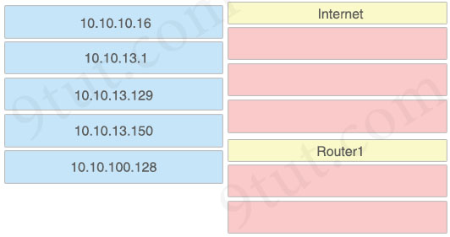
OSPF is running between site A and site B. Drag and drop the destination IPs from the left onto the network segments used to reach the destination on the right.
Answer:
Internet
+ 10.10.10.16
+ 10.10.13.129
+ 10.10.100.128
Router1
+ 10.10.13.1
+ 10.10.13.150
Question 12.67
What is a reason to implement LAG on a Cisco WLC?
A. Enable the connected switch ports to use different Layer 2 configurations.
B. Increase the available throughput on the link.
C. Allow for stateful failover between WLCs.
D. Increase security by encrypting management frames.

Answer: B
Question 12.68
What are two port types used by a Cisco WLC for out-of-band management? (Choose two)
A. redundant
B. distribution system
C. service
D. management
E. console

Answer: C E
Explanation
The service port is used for out-of-band management of the controller and system recovery and maintenance in the event of a network failure.
Reference: https://www.firewall.cx/cisco-technical-knowledgebase/cisco-wireless/1077-cisco-wireless-controllers-interfaces-ports-functionality.html
The console port is used for out-of-band management, system recovery, and early boot operations.
Reference: https://www.geeksforgeeks.org/physical-infrastructure-connections-of-wlan-components/
Question 12.69
Drag and drop the statement about AAA services from the left to the corresponding AAA services on the right.
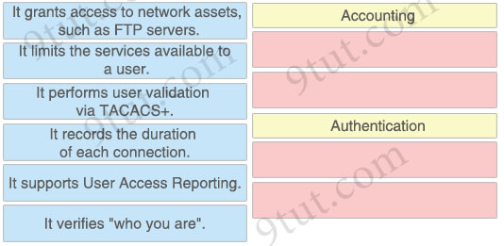

Answer:
Accounting:
+ It records the duration of each connection.
+ It supports User Access Reporting.
Authentication:
+ It performs user validation via TACACS+.
+ It verifies “who you are”.
Question 12.70
Refer to the exhibit.
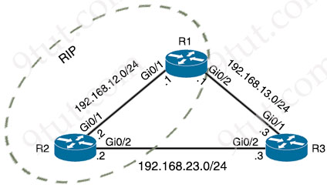
Routers R1 and R2 are configured with RIP as the dynamic routing protocol. A network engineer must configure R1 with floating static route to serve as a backup route to network 192.168.23.0. Which command must the engineer configure on R1?
A. ip route 192.168.23.0 255.255.255.255 192.168.13.3 121
B. ip route 192.168.23.0 255.255.255.0 192.168.13.3 100
C. ip route 192.168.23.0 255.255.255.0 192.168.13.3
D. ip route 192.168.23.0 255.255.255.0 192.168.13.3 121

Answer: D
Explanation
The Administrative Distance (AD) of RIP is 120 so we have to configure a higher AD value (121, for example) for the floating static route to serve as the backup route. Also the subnet mask to this network must be /24 (255.255.255.0).
Question 12.71
What are two facts that differentiate optical-fiber cabling from copper cabling? (Choose two)
A. It carries signals for longer distances.
B. It provides greater throughput options.
C. It carries electrical current further distances for PoE devices.
D. It is less expensive when purchasing patch cables.
E. It has a greater sensitivity to changes in temperature and moisture

Answer: A B
Question 12.72
Why would VRRP be implemented when configuring a new subnet in a multivendor environment?
A. to ensure that the spanning-tree forwarding path to the gateway is loop-free
B. when a gateway protocol is required that supports more than two Cisco devices for redundancy
C. to interoperate normally with all vendors and provide additional security features for Cisco devices
D. to enable normal operations to continue after a member failure without requiring a change in a host ARP cache

Answer: D
Explanation
VRRP is an open standard protocol so it is a must when using along with another vendor.
The first part of answer C is correct but VRRP does not provide additional security features so this answer is not correct.
All VRRP routers share the MAC address of the virtual IP address (in the form 0000.5E00.01xx, where xx is the VRRP group number) so even when a member fails, the hosts do not need to change its ARP cache by sending an ARP request again -> Answer D is correct.
Question 12.73
What must a network administrator consider when deciding whether to configure a new wireless network with APs in autonomous mode or APs running in cloud-based mode?
A. Autonomous mode APs are less dependent on an underlay but more complex to maintain than APs in cloud-based mode
B. Autonomous mode APs are easy to deploy and automate than APs in cloud-based mode
C. Cloud-based mode APs are easy to deploy but harder to automate than APs in autonomous mode
D. Cloud-based mode APs rely on underlays and are more complex to maintain than APs in autonomous mode

Answer: A
Explanation
Autonomous AP can work on it’s own. Cloud-based AP management is an alternative to purchasing a management platform. The AP management function is pushed into the Internet cloud -> The Cloud-based AP is easier to manage than “traditional” autonomous mode APs as we have to configure autonomous APs one by one.
Question 12.74
Under the CRUD model, which two HTTP methods support the UPDATE operation? (Choose two)
A. PUT
B. PATCH
C. DELETE
D. POST
E. GET

Answer: A B
Explanation
CRUD is short for CREATE, READ, UPDATE and DELETE operations. Only UPDATE operation modifies an existing table or view so it is equivalent to PUT and PATCH in HTTP methods.
PUT: fully update (i.e. replace) an existing record
PATCH: update part of an existing record
PUT is similar to POST in that it can create resources, but it does so when there is a defined URL wherein PUT replaces the entire resource if it exists or creates new if it does not exist.
Unlike PUT Request, PATCH does partial update. Fields that need to be updated by the client, only that field is updated without modifying the other field.
Question 12.75
What are two advantages of implementing a controller-based architecture instead of a traditional network architecture? (Choose two)
A. It supports complex and high-scale IP addressing schemes.
B. It provides increased scalability and management options.
C. It allows for seamless connectivity to virtual machines.
D. It enables configuration task automation.
E. It increases security against denial-of-service attacks.

Answer: B D
Question 12.76
Refer to the exhibit.
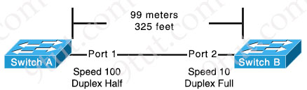
The switches are connected via a Cat5 Ethernet cable that was successfully tested. The interfaces are configured as access ports and are both in a “down” status. What is the cause of this issue?
A. The switches are configured with incompatible duplex settings.
B. The speed settings on the switches are mismatched.
C. The distance between the two switches is not supported by Cat5.
D. The portfast command is missing from the configuration.

Answer: B
Question 12.77
A technician receives a report of network slowness and the issue has been isolated to the interface FastEthernet0/13. What is the root cause of the issue?
FastEthernet0/13 is up, line protocol is up
Hardware is Fast Ethernet, address is 0001.4d27.66cd (bia 0001.4d27.66cd)
MTU 1500 bytes, BW 100000 Kbit, DLY 100 usec,
reliability 250/255, txload 1/255, ndoad 1/255
Encapsulation ARPA, loopback not set
Keepalive not set
Auto-duplex (Full), Auto Speed (100), 100BaseTX/FX
ARP type: ARPA, ARP Timeout 04:00:00
Last input 18:52:43, output 00:00:01, output hang never
Last clearing of "show interface" counters never
Queueing strategy: fifo
Output queue 0/40,0 drops; input queue 0/75, 0 drops
5 minute input rate 12000 bits/sec, 6 packets/sec
5 minute output rate 24000 bits/sec, 6 packets/sec
14488019 packets input, 2441805322 bytes
Received 345346 broadcasts, 0 runts, 0 giants, 0 throttles
261028 input errors, 259429 CRC, 1599 frame, 0 overrun, 0 ignored
0 watchdog, 84207 multicast 0 input packets with dribble condition detected
19658279 packets output, 3529106068 bytes, 0 underruns
0 output errors, 0 collisions, 1 interface resets
0 babbles, 0 late collision, 0 deferred
0 lost carrier, 0 no carrier
0 output buffer failures, 0 output buffers swapped out
A. physical errors
B. local buffer overload
C. duplicate IP addressing
D. err-disabled port on the far end

Answer: A
Explanation
In this question, the input errors and CRC errors grow so the most likely cause of this problem is cable connected between two devices is faulty (physical errors).
Question 12.78
A router received three destination prefixes: 10.0.0.0/8, 10.0.0.0/16, and 10.0.0.0/24. When the show ip route command is executed, which output does it return?
A. Gateway of last resort is 172.16.1.1 to network 0.0.0.0
O E2 10.0.0.0/24[110/5] via 192.168.3.1, 0:01:00, Ethernet2
B. Gateway of last resort is 172.16.1.1 to network 0.0.0.0
O E2 10.0.0.0/16[110/5] via 192.168.2.1, 0:01:00, Ethernet1
O E2 10.0.0.0/24[110/5] via 192.168.3.1, 0:01:00, Ethernet2
C. Gateway of last resort is 172.16.1.1 to network 0.0.0.0
O E2 10.0.0.0/8 [110/5] via 192.168.1.1, 0:01:00, Ethernet0
D. Gateway of last resort is 172.16.1.1 to network 0.0.0.0
O E2 10.0.0.0/8 [110/5] via 192.168.1.1, 0:01:00, Ethernet0
O E2 10.0.0.0/16[110/5] via 192.168.2.1, 0:01:00, Ethernet1
O E2 10.0.0.0/24[110/5] via 192.168.3.1, 0:01:00, Ethernet2

Answer: D
Explanation
For the purpose of installing routes in the routing table, the router considers different prefix lengths as different destinations. That is why multiple routes from the same and/or different routing protocols are installed in the routing table. Tie breaker is longest match rule, that selects the route with the longest subnet mask (prefix length) from among routes already in the routing table.
Reference: https://www.cisconetsolutions.com/introduction-to-routing-protocols/
Question 12.79
Refer to the exhibit.
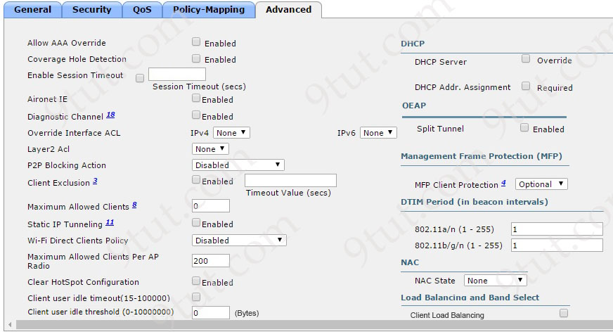
A network engineer configures the CCNA WLAN so that clients must reauthenticate hourly and to limit the number of simultaneous connections to the WLAN to 10. Which two actions complete this configuration? (Choose two)
A. Set the Maximum Allowed Clients value to 10.
B. Enable the Client Exclusion option and set the value to 3600.
C. Set the Maximum Allowed Clients Per AP Radio value to 10.
D. Enable the Wi-Fi Direct Clients Policy option.
E. Enable the Enable Session Timeout option and set the value to 3600.

Answer: A E
Explanation
By default, client sessions with the WLAN are limited to 1800 seconds (30 minutes). Once that session time expires, a client will be required to re-authenticate. This setting is controlled by the Enable Session Timeout check box and the Timeout field.
Question 12.80
Which state is bypassed in Rapid PVST+ when PortFast is enabled on a port?
A. discarding
B. learning
C. blocking
D. forwarding

Answer: B
Explanation
PortFast causes a switch or trunk port to enter the spanning tree forwarding state immediately, bypassing the listening and learning states.
Reference: https://www.cisco.com/c/en/us/td/docs/switches/lan/catalyst4000/8-2glx/configuration/guide/stp_enha.html
Question 12.81
When a switch receives a frame from an unknown source MAC address, which action does the switch take with the frame?
A. It floods the frame out all interfaces, including the interface it was received on.
B. It attempts to send the frame back to the source to ensure that the source MAC address is still available for transmissions.
C. It sends the frame to ports within the CAM table identified with an unknown source MAC address.
D. It associate the source MAC address with the LAN port on which it was received and saves it to the MAC address table.

Answer: D
Question 12.82
What is a function of a southbound API?
A. Automate configuration changes between a server and a switching fabric.
B. Manage flow control between an SDN controller and a switching fabric.
C. Use orchestration to provision a virtual server configuration from a web server.
D. Facilitate the information exchange between an SDN controller and application.

Answer: B
Question 12.83
Which interface condition is occurring in this output?
R25# show interface fa0/0
FastEthernet0/0 is up, line protocol is up
Hardware is DEC21140, address is ca02.7788.0000 (bia ca02.7788.0000)
Description: atlanta_subnet
Internet address is 10.32.102.2/30
MTU 1500 bytes, BW 100000 Kbit/sec, DLY 100 usec,
reliability 255/255, txload 1/255, rxload 1/255
Encapsulation ARPA, loopback not set
Keepalive set (60 sec)
Full-duplex, 100 Mb/s, 100BaseTX/FX
ARP type: ARPA, ARP Timeout 04:00:00
Last input 00:00:01, output 00:00:00, output hang never
Last clearing of "show interface" counters never
Input queue: 0/300/0/0 (size/max/drops/flushes); Total output drops: 0
Queueing strategy: fifo
Output queue: 0/300 (size/max)
30 second input rate 0 bits/sec, 0 packets/sec
30 second output rate 0 bits/sec, 0 packets/sec
7331 packets input, 7101162 bytes
Received 267 broadcasts (0 IP multicasts)
1876 runts, 0 giants, 0 throttles
0 input errors, 0 CRC, 0 frame, 0 overrun, 0 ignored
0 watchdog
0 input packets with dribble condition detected
3927 packets output, 1440403 bytes, 0 underruns
0 output errors, 0 collisions, 0 interface resets
0 unknown protocol drops
0 babbles, 0 late collision, 0 deferred
0 lost carrier, 0 no carrier
0 output buffer failures, 0 output buffers swapped out
A. bad NIC
B. duplex mismatch
C. collisions
D. high throughput

Answer: A
Explanation
In the output we see a high number of runts (“1876 runts”). Runts are frames which do not meet the minimum frame size of 64 bytes. Although runts are usually created by collisions but it is not the reason for this question because the collision in the output above is 0.
There is another usual cause of excessive runt frames, which is malfunctioning (bad) NICs.
Reference: https://www.ii.pwr.edu.pl/~kano/course/module2/2.1.2.5/2.1.2.5.html
Question 12.84
Which interface condition is occurring in this output?
R25# show interface fa0/0
FastEthernet0/0 is up, line protocol is up
Hardware is DEC21140, address is ca02.7788.0000 (bia ca02.7788.0000)
Description: singapore_subnet
Internet address is 10.32.102.2/30
MTU 1500 bytes, BW 100000 Kbit/sec, DLY 100 usec,
reliability 255/255, txload 255/255, rxload 255/255
Encapsulation ARPA, loopback not set
Keepalive set (60 sec)
Full-duplex, 100 Mb/s, 100BaseTX/FX
ARP type: ARPA, ARP Timeout 04:00:00
Last input 00:00:01, output 00:00:00, output hang never
Last clearing of "show interface" counters never
Input queue: 0/300/0/0 (size/max/drops/flushes); Total output drops: 0
Queueing strategy: fifo
Output queue: 0/300 (size/max)
30 second input rate 225953751 bits/sec, 0 packets/sec
30 second output rate 232423817 bits/sec, 0 packets/sec
7331 packets input, 7101162 bytes
Received 267 broadcasts (0 IP multicasts)
0 runts, 0 giants, 0 throttles
0 input errors, 0 CRC, 0 frame, 0 overrun, 0 ignored
0 watchdog
0 input packets with dribble condition detected
3927 packets output, 1440403 bytes, 0 underruns
0 output errors, 0 collisions, 0 interface resets
0 unknown protocol drops
0 babbles, 0 late collision, 0 deferred
0 lost carrier, 0 no carrier
0 output buffer failures, 0 output buffers swapped out
A. bad NIC
B. duplex mismatch
C. collisions
D. high throughput

Answer: D
Explanation
Both txload and rxload on this interface are “255/255” so this interface is busy in transmitting and receiving traffic.
Question 12.85
The clients and DHCP server reside on different subnets. Which command must be used to forward requests and replies between clients on the 10.10.0.1/24 subnet and the DHCP server at 192.168.10.1?
A. ip route 192.168.10.1
B. ip helper-address 192.168.10.1
C. ip dhcp address 192.168.10.1
D. ip default-gateway 192.168.10.1

Answer: B
Explanation
To make a router a DHCP Relay Agent, simply put the “ip helper-address <IP-address-of-DHCP-Server>” command under the interface that receives the DHCP messages from the DHCP Client.
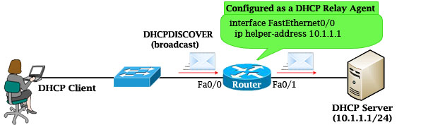
Question 12.86
What is the PUT method within HTTP?
A. It replaces data at the destination.
B. It displays a web site.
C. It is a read-only operation.
D. It is a nonidempotent operation.

Answer: A
Explanation
The HTTP PUT request method creates a new resource or replaces a representation of the target resource with the request payload -> Answer A is correct.
The difference between PUT and POST is that PUT is idempotent: calling it once or several times successively has the same effect (that is no side effect), whereas successive identical POST requests may have additional effects, akin to placing an order several times -> Answer D is not correct.
Reference: https://developer.mozilla.org/en-US/docs/Web/HTTP/Methods/PUT
Question 12.87
Refer to the exhibit.
R1
interface GigabitEthernet0/1
ip address 192.168.12.1 255.255.255.128
no shutdown
router ospf 1
network 192.168.12.1 0.0.0.0 area 1

R2
interface GigabitEthernet0/1
ip address 192.168.12.2 255.255.255.128
no shutdown
A network engineer started to configure two directly-connected routers as shown. Which command sequence must the engineer configure on R2 so that the two routers become OSPF neighbors?
A. interface GigabitEthernet0/1
ip ospf 1 area 0
B. interface GigabitEthernet0/1
ip ospf 1 area 1
C. router ospf 1
network 192.168.12.0 0.0.0.127 area 0
D. router ospf 1
network 192.168.12.1 0.0.0.0 area 1

Answer: B
Explanation
To establish OSPF neighbor between R1 & R2, interface Gi0/1 of R2 must belong to the same area of interface Gi0/1 of R1 (area 1) and OSPF must be turned on on this interface via “ip ospf 1 area 1” command or “network 192.168.12.2 0.0.0.0 area 1″ command or “network 192.168.12.0 0.0.0.127 area 1” command…
Question 12.88
Refer to the exhibit.
R1# show ip route
Codes: C - connected, S - static, I - IGRP, R - rip, M - mobile, B - BGP
D - EIGRP, EX - EIGRP external, O - OSPF, IA - OSPF inter area
N1 - OSPF NSSA external type 1, N2 - OSPF NSSA external type 2
E1 - OSPF external type 1, E2 - OSPF external type 2, E - EGP
i - IS-IS, L1 - IS-IS level-1, L2 - IS-IS level-2, * - candidate
default
U - per-user static route, o - ODR
Gateway of last resort is not set
C 10.0.0.0/8 is directly connected, Loopback0
10.0.0.0/8 is variably subnetted, 4 subnets, 2 masks
O 10.0.1.3/32 [110/100] via 10.0.1.100, 00:39:08, Serial0
C 10.0.1.0/24 is directly connected, Serial0
O 10.0.1.5/32 [110/5] via 10.0.1.50, 00:39:08, Gigabit Ethernet 0/0
D 10.0.1.4/32 [110/10] via 10.0.1.4, 00:39:08, Gigabit Ethernet 0/0
What does route 10.0.1.3/32 represent in the routing table?
A. all hosts in the 10.0.1.0 subnet
B. the source 10.0.1.100
C. a single destination address
D. the 10.0.0.0 network

Answer: C
Question 12.89
Refer to the exhibit.
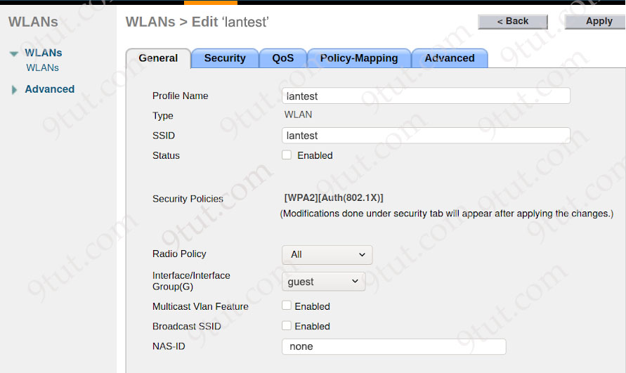
A Cisco engineer creates a new WLAN called lantest. Which two actions must be performed so that only high-speed 2.4-Ghz clients connect? (Choose two)
A. Enable the Status option.
B. Set the Interface/Interface Group(G) to an interface other than guest.
C. Set the Radio Policy option to 802.11g only.
D. Set the Radio Policy option to 802.11a only.
E. Enable the Broadcast SSID option.

Answer: A C
Explanation
First we need to enable this WLAN -> Answer A is correct.
+ 802.11a: Operates in the 5 GHz band only and supports a maximum data rate of 54 Mbps -> Answer D is not correct.
+ 802.11g: Operates in the 2.4 GHz band only and supports a maximum data rate of 54 Mbps
Question 12.90
Refer to the exhibit.
Which two values does router R1 use to determine the best path to reach destinations in network 1.0.0.0/8? (Choose two)
A. longest prefix match
B. lowest cost to reach the next hop
C. highest administrative distance
D. highest metric
E. lowest metric

Answer: A E
Question 12.91
An engineer is configuring SSH version 2 exclusively on the R1 router. What is the minimum configuration required to permit remote management using the cryptographic protocol?
Option A  hostname R1  ip domain name cisco  crypto key generate rsa general-keys modulus 1024  username cisco privilege 15 password 0 cisco123  ip ssh version 2  line vty 0 15  transport input all  login local | Option B  hostname R1  crypto key generate rsa general-keys modulus 1024  username cisco privilege 15 password 0 cisco123  ip ssh version 2  line vty 0 15  transport input all  login local
Option C  hostname R1  service password-encryption  crypto key generate rsa general-keys modulus 1024  username cisco privilege 15 password 0 cisco123  ip ssh version 2  line vty 0 15  transport input ssh  login local | Option D  hostname R1  ip domain name cisco  crypto key generate rsa general-keys modulus 1024  username cisco privilege 15 password 0 cisco123  ip ssh version 2  line vty 0 15  transport input ssh  login local
A. Option A
B. Option B
C. Option C
D. Option D

Answer: D
Explanation
This question said “configuring SSH version 2 exclusively” so only SSHv2 should be configured to remote access to this router -> We must use the command “transport input ssh”, not “transport input all” (which includes Telnet) -> Only Option C and Option D are correct.
We must create a domain-name too for SSH to work with the command “ip domain-name …” -> Only Option D is correct.
Note: There is a typo in this question in the command “ip domain name …”. It should be “ip domain-name …” instead.
Question 12.92
Refer to the exhibit.
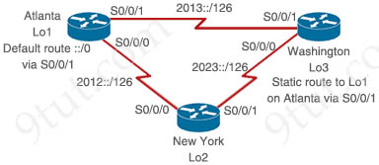
Configured routers IPv6 addresses:
Atlanta:  S0/0/0: 2012::1/126  S0/0/1: 2013::1/126  Loopback1: 2000::1/128 | New York:  S0/0/0: 2012::2/126  S0/0/1: 2023::2/126  Loopback2:2000::2/128 | Washington:  S0/0/0: 2023::3/126  S0/0/1: 2013::3/126  Loopback3: 2000::3/128
The New York router must be configured so that traffic to 2000::1 is sent primarily via the Atlanta site, with a secondary path via Washington that has an administrative distance of 2. Which two commands must be configured on the New York router? (Choose two)
A. ipv6 route 2000::1/128 2012::1 5
B. ipv6 route 2000::1/128 2023::2 5
C. ipv6 route 2000::1/128 2012::1
D. ipv6 route 2000::1/128 2023::3 2
E. ipv6 route 2000::1/128 2012::2

Answer: C D
Question 12.93
Which interface condition is occurring in this output?
R19# show interface fa0/0
FastEthernet0/0 is up, line protocol is up
Hardware is DEC21140, address is ca02.7788.0000 (bia ca02.7788.0000)
Description: portland_subnet
Internet address is 10.32.102.2/30
MTU 1500 bytes, BW 100000 Kbit/sec, DLY 100 usec,
reliability 255/255, txload 1/255, rxload 1/255
Encapsulation ARPA, loopback not set
Keepalive set (60 sec)
Full-duplex, 100 Mb/s, 100BaseTX/FX
ARP type: ARPA, ARP Timeout 04:00:00
Last input 00:00:01, output 00:00:00, output hang never
Last clearing of "show interface" counters never
Input queue: 0/300/0/0 (size/max/drops/flushes); Total output drops: 0
Queueing strategy: fifo
Output queue: 0/300 (size/max)
30 second input rate 0 bits/sec, 0 packets/sec
30 second output rate 0 bits/sec, 0 packets/sec
7331 packets input, 7101162 bytes
Received 267 broadcasts (0 IP multicasts)
0 runts, 0 giants, 0 throttles
0 input errors, 0 CRC, 0 frame, 0 overrun, 0 ignored
0 watchdog
0 input packets with dribble condition detected
3927 packets output, 1440403 bytes, 0 underruns
0 output errors, 139 collisions, 0 interface resets
0 unknown protocol drops
0 babbles, 0 late collision, 0 deferred
0 lost carrier, 0 no carrier
0 output buffer failures, 0 output buffers swapped out
A. queueing
B. duplex mismatch
C. collisions
D. high throughput

Answer: B
Explanation
This interface gets high collision (139 collisions) so one end may be set to “Half-duplex”.
Question 12.94
A router has two static routes to the same destination network under the same OSPF process. How does the router forward packets to the destination if the next-hop devices are different?
A. The router chooses the next hop with the lowest IP address.
B. The router load-balances traffic over all routes to the destination.
C. The router chooses the next hop with the lowest MAC address.
D. The router chooses the route with the oldest age.

Answer: B
Explanation
You can add multiple static routes for the same destination network to provide one or more of the following benefits:
+ IP load balancing – When you add multiple IP static routes for the same destination to different next-hop gateways, and the routes each have the same metric and administrative distance, the Layer 3 switch can load balance traffic to the routes’ destination.
+ Path redundancy – When you add multiple static IP routes for the same destination, but give the routes different metrics or administrative distances, the Layer 3 switch uses the route with the lowest administrative distance by default, but uses another route to the same destination if the first route becomes unavailable.
Reference: https://docs.ruckuswireless.com/fastiron/08.0.40/fastiron-08040a-l3guide/GUID-FE67DB45-70C8-420D-AE8A-AEF36F4CF53D.html
Question 12.95
Which interface condition is occurring in this output?
R17# show interface fa0/0
FastEthernet0/0 is up, line protocol is up
Hardware is DEC21140, address is ca02.7788.0000 (bia ca02.7788.0000)
Description: chicago_subnet
Internet address is 10.32.102.2/30
MTU 1500 bytes, BW 100000 Kbit/sec, DLY 100 usec,
reliability 255/255, txload 255/255, rxload 255/255
Encapsulation ARPA, loopback not set
Keepalive set (60 sec)
Full-duplex, 100 Mb/s, 100BaseTX/FX
ARP type: ARPA, ARP Timeout 04:00:00
Last input 00:00:01, output 00:00:00, output hang never
Last clearing of "show interface" counters never
Input queue: 0/300/0/0 (size/max/drops/flushes); Total output drops: 0
Queueing strategy: fifo
Output queue: 0/300 (size/max)
30 second input rate 201240151 bits/sec, 0 packets/sec
30 second output rate 228594263 bits/sec, 0 packets/sec
7331 packets input, 7101162 bytes
Received 267 broadcasts (0 IP multicasts)
1876 runts, 0 giants, 0 throttles
0 input errors, 0 CRC, 0 frame, 0 overrun, 0 ignored
0 watchdog
0 input packets with dribble condition detected
3927 packets output, 1440403 bytes, 0 underruns
0 output errors, 0 collisions, 0 interface resets
0 unknown protocol drops
0 babbles, 0 late collision, 0 deferred
0 lost carrier, 0 no carrier
0 output buffer failures, 0 output buffers swapped out
A. high throughput
B. queueing
C. bad NIC
D. broadcast storm

Answer: A
Explanation
We see the line “txload 255/255, rxload 255/255” which means this interface is busy in transmitting and receiving traffic so there are two answers: “high throughput” and “broadcast storm”. But the number of broadcast messages are not big (“Received 267 broadcasts”) while we have “7331 packets input” and “3927 packets output” so we don’t have a broadcast storm here.
Note: There are no errors (0 input errors, 0 CRC) so “bad NIC” is not a good answer.
+ input errors: This counter will increase when the interface receives a frame with any kind of error, this includes runts, giants, no buffer available, CRC errors, etc.
+ CRC: The number of packets received with CRC (Cyclic Redundancy Checksum) errors. This means that the checksum that was generated by the sender does not match the checksum that the receiver calculated. On a LAN this typically occurs when you have issues with cabling or defective network cards.
Question 12.96
Which property is shared by 10GBase-SR and 10GBase-LR interfaces?
A. Both use the multimode fiber type.
B. Both require UTP cable media for transmission.
C. Both use the single-mode fiber type.
D. Both require fiber cable media for transmission.

Answer: D
Explanation
10GBASE-SR (“short range”) is a port type for multi-mode fiber and uses 850 nm lasers.
10GBASE-LR is a 10 Gigabit Ethernet standard specified to transmit data over long distance (the letters “LR” refers to “long reach”) through single mode fiber.
Question 12.97
A network engineer is upgrading a small data center to host several new applications, including server backups that are expected to account for up to 90% of the bandwidth during peak times. The data center connects to the MPLS network provider via a primary circuit and a secondary circuit. How does the engineer inexpensively update the data center to avoid saturation of the primary circuit by traffic associated with the backups?
A. Place the backup servers in a dedicated VLAN.
B. Configure a dedicated circuit for the backup traffic.
C. Assign traffic from the backup servers to a dedicated switch.
D. Advertise a more specific route for the backup traffic via the secondary circuit.

Answer: D
Explanation
Answer A is not correct as a dedicated VLAN does not affect how the traffic goes. It only helps separate Layer 2 traffic at the data center side.
Answer B and answer C are not correct as using a dedicated circuit and dedicated switch are expensive.
Only answer D is left and this solution is “inexpensive”. By routing a group of customer to use the secondary circuit we can avoid saturation of the primary circuit during the peak times.
Question 12.98
Refer to the exhibit.
R1#show ip ospf interface g0/0/0
GigabitEthernet0/0/0 is up, line protocol is up
Internet address is 192.168.1.2/24, Area 0
Process ID 1, Router ID 192.168.1.2, Network Type POINT-TO-POINT, Cost: 1
Transmit Delay is 1 sec, State POINT-TO-POINT,
Timer intervals configured, Hello 10, Dead 40, Wait 40, Retransmit 5
Hello due in 00:00:08
Index 1/1, flood queue length 0
Next 0x0(0) /0x0(0)
Last flood scan length is 1, maximum is 1
Last flood scan time is 0 msec, maximum is 0 msec
Suppress hello for 0 neighbor(s)

R2#show ip ospf interface g0/0/0
GigabitEthernet0/0/0 is up, line protocol is up
Internet address is 192.168.1.1/24, Area 0
Process ID 1, Router ID 10.1.1.1, Network Type POINT-TO-POINT, Cost: 1
Transmit Delay is 1 sec, State POINT-TO-POINT,
Timer intervals configured, Hello 15, Dead 40, Wait 40, Retransmit 5
Hello due in 00:00:11
Index 1/1, flood queue length 0
Next 0x0(0)/0x0(0)
Last flood scan length is 1, maximum is 1
Last flood scan time is 0 msec, maximum is 0 msec
Suppress hello for 0 neighbor(s)
The network engineer is configuring router R2 as a replacement router on the network. After the initial configuration is applied it is determined that R2 failed to show R1 as a neighbor. Which configuration must be applied to R2 to complete the OSPF configuration and enable it to establish the neighbor relationship with R1?
Option A  R2(config)#interface g0/0/0  R2(config-if)#ip ospf hello-interval 10 | Option B  R2(config)#router ospf 1  R2(config-router)#router-id 192.168.1.1
Option C  R2(config)#router ospf 1  R2(config-router)#network 192.168.1.0 255.255.255.0 area 2 | Option D  R2(config)#interface g0/0/0  R2(config-if)#ip ospf dead-interval 45
A. Option A
B. Option B
C. Option C
D. Option D

Answer: A
Explanation
In order to become OSPF neighbor, the following values must be matched on both routers:
+ Area ID
+ Authentication
+ Hello and Dead Intervals
+ Stub area Flag
+ MTU Size
In this question we see the Hello intervals are mismatched (“10” seconds on R1 and “15” seconds on R2) so we must correct it on one end.
Question 12.99
What are two characteristics of a small office / home office connection environment? (Choose two)
A. It supports between 1 and 50 users.
B. It requires a core, distribution, and access layer architecture.
C. It supports between 50 and 100 users.
D. A router port connects to a broadband connection.
E. It requires 10Gb ports on all uplinks.

Answer: A D
Explanation
SOHO networks are small LANs (Local Area Networks). Typically, SOHO networks consists of less than 10 computers.
A SOHO network connected to a router permits all connected PCs to share high-speed Internet access.
Reference: https://www.oreilly.com/library/view/soho-networking-a/0130473316/0130473316_ch05.html
Question 12.100
Which syslog severity level is considered the most severe and results in the system being considered unusable?
A. Critical
B. Emergency
C. Alert
D. Error

Answer: B
Explanation
The Syslog levels are:
Level | Keyword | Description
0 | emergencies | System is unusable
1 | alerts | Immediate action is needed
2 | critical | Critical conditions exist
3 | errors | Error conditions exist
4 | warnings | Warning conditions exist
5 | notification | Normal, but significant, conditions exist
6 | informational | Informational messages
7 | debugging | Debugging messages
Question 12.101
Drag and drop the statements about AAA from the left onto the corresponding AAA services on the right. Not all options are used.
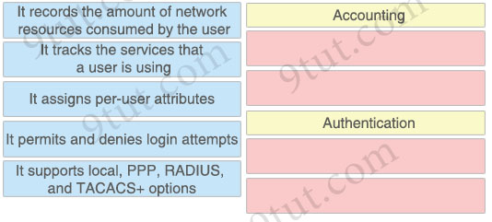

Answer:
Accounting:
+ It records the amount of network resources consumed by the user
+ It tracks the services that a user is using
Authentication:
+ It permits and denies login attempts
+ It supports local, PPP, RADIUS, and TACACS+ options
Explanation
Accounting tracks the services that a user is using. For example, it can log what commands were issued by a user.
Authentication also supports PPP via the “aaa authentication ppp …” command.
Authorization assigns per-user attributes.
Question 12.102
Which benefit does Cisco DNA Center provide over traditional campus management?
A. Cisco DNA Center leverages SNMPv3 for encrypted management, and traditional campus management uses SNMPv2.
B. Cisco DNA Center leverages APIs, and traditional campus management requires manual data gathering.
C. Cisco DNA Center automates SSH access for encrypted entry, and SSH is absent from traditional campus management.
D. Cisco DNA Center automates HTTPS for secure web access, and traditional campus management uses HTTP.

Answer: B
Question 12.103
Which interface condition is occurring in this output?
R25# show interface fa0/0
FastEthernet0/0 is up, line protocol is up
Hardware is DEC21140, address is ca02.7788.0000 (bia ca02.7788.0000)
Description: tokyo_subnet
Internet address is 10.32.102.2/30
MTU 1500 bytes, BW 100000 Kbit/sec, DLY 100 usec,
reliability 255/255, txload 1/255, rxload 1/255
Encapsulation ARPA, loopback not set
Keepalive set (60 sec)
Full-duplex, 100 Mb/s, 100BaseTX/FX
ARP type: ARPA, ARP Timeout 04:00:00
Last input 00:00:01, output 00:00:00, output hang never
Last clearing of "show interface" counters never
Input queue: 0/300/0/0 (size/max/drops/flushes); Total output drops: 0
Queueing strategy: fifo
Output queue: 185/300 (size/max)
30 second input rate 0 bits/sec, 0 packets/sec
30 second output rate 0 bits/sec, 0 packets/sec
7331 packets input, 7101162 bytes
Received 267 broadcasts (0 IP multicasts)
1876 runts, 0 giants, 0 throttles
0 input errors, 0 CRC, 0 frame, 0 overrun, 0 ignored
0 watchdog
0 input packets with dribble condition detected
3927 packets output, 1440403 bytes, 0 underruns
0 output errors, 0 collisions, 0 interface resets
0 unknown protocol drops
0 babbles, 0 late collision, 0 deferred
0 lost carrier, 0 no carrier
0 output buffer failures, 0 output buffers swapped out
A. bad NIC
B. broadcast storm
C. queueing
D. duplex mismatch

Answer: C
Explanation
We see the line “Output queue: 185/300” so this interface has many packets held in the output queue.
Question 12.104
Drag and drop the characteristics of northbound APIs from the left onto any position on the right. Not all characteristics are used.
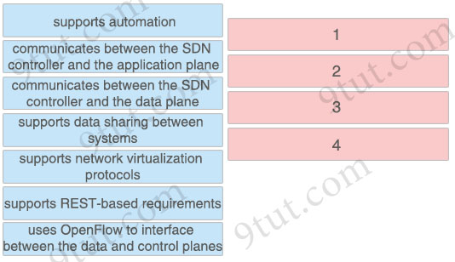

Answer:
+ supports automation
+ communicates between the SDN controller and the application plane
+ supports network virtualization protocols
+ supports REST-based requirements
Explanation
SDN northbound APIs are usually RESTful APIs used to communicate between the SDN Controller and the services and applications running over the network.
The networking administrators and SDN applications want to control the controller. So the controller need a northbound interface (NBI) to communicate with us. The NBI applications included various network services, including network virtualization, dynamic virtual network provisioning, firewall monitoring, user identity management and access policy control.
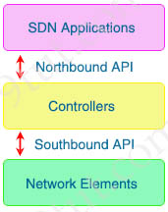
Question 12.105
What is the role of community strings in SNMP operations?
A. It serves as a sequence tag on SNMP traffic messages.
B. It serves as a password to protect access to MIB objects.
C. It passes the Active Directory username and password that are required for device access.
D. It translates alphanumeric MIB output values to numeric values.

Answer: B
Explanation
SNMP community strings authenticate access to MIB objects and function as embedded passwords.
Reference: https://www.cisco.com/en/US/docs/switches/lan/catalyst3850/software/release/3se/consolidated_guide/b_consolidated_3850_3se_cg_chapter_01100010.html
Question 12.106
Drag and drop the statements about access-point modes from the left onto the corresponding modes on the right.
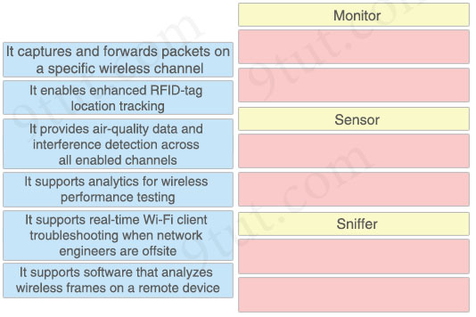

Answer:
Monitor:
+ It enables enhanced RFID-tag location tracking.
+ It provides air-quality data and interference detection across all enabled channels
Sensor:
+ It supports real-time Wi-Fi client troubleshooting when network engineers are offsite
+ It supports analytics for wireless performance testing
Sniffer:
+ It captures and forwards packets on a specific wireless channel
+ It supports software that analyzes wireless frames on a remote device
Explanation
+ Monitor mode: does not transmit at all. It acts like a dedicated sensor for location-based services (LBS), rogue AP detection, and Checks Intrusion Detection System (IDS). In this mode, AP will not broadcast an SSID so clients are unable to connect to it.
+ Sniffer mode: run as a sniffer and captures and forwards all the packets on a particular channel to a remote machine where you can use protocol analysis tool (Wireshark, Airopeek, etc) to review the packets and diagnose issues. Strictly used for troubleshooting purposes.
+ Sensor mode: this is a special mode which is not listed in the books but you need to know. In this mode, the device can actually function much like a WLAN client would associating and identifying client connectivity issues within the network in real time without requiring an IT or technician to be on site.
From https://www.cisco.com/c/en/us/td/docs/wireless/controller/9800/config-guide/b_wl_16_10_cg/monitor-mode.pdf:
Introduction to Monitor Mode
To optimize the monitoring and location calculation of RFID tags, you can enable tracking optimization on
up to four channels within the 2.4-GHz band of an 802.11b/g/x access point radio.
From https://www.cisco.com/c/en/us/td/docs/wireless/controller/9800/17-8/config-guide/b_wl_17_8_cg/m_environmental_sensors_on_aps.pdf:
The Environmental Sensors in Access Points feature helps you collect real-time environmental data, such as,
air quality, temperature, and humidity, from the environmental sensors. The advantage of sensor mode is to allow the AP to use its own radio (as a client) to test the quality and performance of the network at any time.
Reference: https://www.cisco.com/c/en/us/td/docs/wireless/controller/technotes/8-6/b_Cisco_Aironet_Sensor_Deployment_Guide.html
Monitor – When Cisco CleanAir is enabled in monitor mode, the access point provides air quality and interference detection reports for all monitored channels.
Reference: https://www.cisco.com/en/US/docs/switches/lan/catalyst3650/software/release/3se/consolidated_guide/configuration_guide/b_consolidated_3850_3se_cg_chapter_011011.html
Question 12.107
Refer to the exhibit.
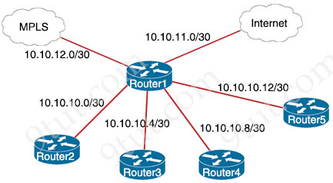
Router1#show ip route
Gateway of last resort is 10.10.11.2 to network 0.0.0.0
209.165.200.0/27 is subnetted, 1 subnets
B 209.165.200.224 [20/0] via 10.10.12.2, 03:32:14
209.165.201.0/27 is subnetted, 1 subnets
B 209.165.201.0 [20/0] via 10.10.12.2, 02:26:53
209.165.202.0/27 is subnetted, 1 subnets
B 209.165.202.128 [20/0] via 10.10.12.2, 02:46:03
10.0.0.0/8 is variably subnetted, 10 subnets, 4 masks
O 10.10.13.0/25 [110/2] via 10.10.10.1, 00:00:04, GigabitEthernet0/0
O 10.10.13.128/28 [110/2] via 10.10.10.5, 00:00:12, GigabitEthernet0/1
O 10.10.13.144/28 [110/2] via 10.10.10.9, 00:01:57, GigabitEthernet0/2
O 10.10.13.160/29 [110/2] via 10.10.10.5, 00:00:12, GigabitEthernet0/1
O 10.10.13.208/29 [110/2] via 10.10.10.13, 00:01:57, GigabitEthernet0/3
S* 0.0.0.0/0 [1/0] via 10.10.11.2
Drag and drop the destination IPs from the left onto the paths to reach those destinations on the right.
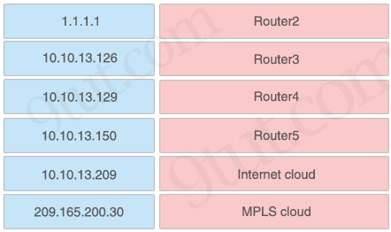

Answer:
+ Router 2: 10.10.13.126
+ Router 3: 10.10.13.129
+ Router 4: 10.10.13.150
+ Router 5: 10.10.13.209
+ Internet cloud: 1.1.1.1
+ MPLS cloud: 209.165.200.30
Explanation
Maybe there was a typo for this question for the match “MPLS cloud: 209.165.200.30”. The output is not correct as 209.165.200.0/27 does not include 209.165.200.224/27. But we still choose the best answer for this choice and it is 209.165.200.224/27 for destination IP 209.165.200.30.
Question 12.108
Drag and drop the IPv6 address descriptions from the left onto the IPv6 address types on the right. Not all options are used.
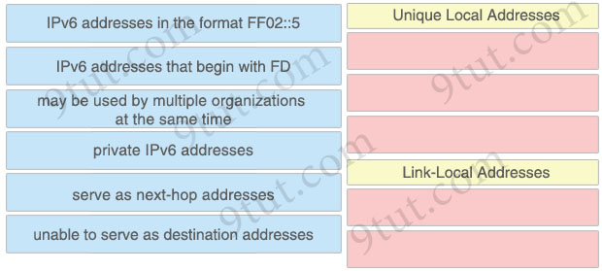

Answer:
Unique Local Addresses
+ IPv6 addresses that begin with FD
+ may be used by multiple organizations at the same time
+ private IPv6 addresses
Link-Local Addresses
+ serve as next-hop addresses
+ unable to serve as destination addresses
Explanation
Unique local address (or Site-local address) are analogous to IPv4’s private address classes. They start with FC00::/7 (for used in private networks) -> The first octet can be FC or FD. However when you implement this you have to set the L-bit (the right-most bit of the first octet) to 1 which means that the first two digits will be FD.
FF02::5 is a multicast address (not a link-local address). It only has a link-local scope (an IPv6 router never forwards this type of traffic beyond the local link) so this IPv6 address does not belong to “link-local addresses”.
You can use either Global Unicast IPv6 address or Link-Local IPv6 address as the next hop address. However, if you provide the Link-Local IPv6 address as the next hop address, you need to provide the interface number also.
Refefence: https://www.omnisecu.com/cisco-certified-network-associate-ccna/how-to-configure-ipv6-static-routes-in-cisco-routers.php
Question 12.109 (similar to an old question)
How will Link Aggregation be implemented on a Cisco Wireless LAN Controller?
A. To pass client traffic, two or more ports must be configured
B. The EtherChannel must be configured in “mode active”
C. When enabled, the WLC bandwidth drops to 500 Mbps
D. One functional physical port is needed to pass client traffic

Answer: D
Explanation
Link aggregation (LAG) is a partial implementation of the 802.3ad port aggregation standard. It bundles all of the controller’s distribution system ports into a single 802.3ad port channel.
Restriction for Link aggregation:
+ LAG requires the EtherChannel to be configured for ‘mode on’ on both the controller and the Catalyst switch -> Answer B is not correct.
+ If the recommended load-balancing method cannot be configured on the Catalyst switch, then configure the LAG connection as a single member link or disable LAG on the controller -> Answer A is not correct while answer D is correct.
Reference: https://www.cisco.com/c/en/us/td/docs/wireless/controller/7-5/configuration-guide/b_cg75/b_cg75_chapter_0100010.html
Question 12.110 (similar to an old question)
Refer to the exhibit.
Switch(config)#hostname R1
R1(config)#interface FastEthernet0/1
R1(config-if)#no switchport
R1(config-if)#ip address 10.100.20.42 255.255.255.0
R1(config-if)#line vty 0 4
R1(config-line)#login
An engineer booted a new switch and applied this configuration via the console port. Which additional configuration must be applied to allow administrators to authenticate directly to global configuration mode via Telnet using a local username and password?
A.
R1(config)#username admin
R1(config-if)#line vty 0 4
R1(config-line)#password p@ss1234
B.
R1(config)#username admin
R1(config-if)#line vty 0 4
R1(config-line)#password p@ss1234
R1(config-line)#transport input telnet
C.
R1(config)#username admin secret p@ss1234
R1(config-if)#line vty 0 4
R1(config-line)#login local
R1(config)#enable secret p@ss1234
D.
R1(config)#username admin privilege 15 secret p@ss1234
R1(config-if)#line vty 0 4
R1(config-line)#login local

Answer: D
Question 12.111
What is the definition of backdoor malware?
A. malicious program that is used to launch other malicious programs
B. malicious code that infects a user machine and then uses that machine to send spam
C. malicious code with the main purpose of downloading other malicious code
D. malicious code that is installed onto a computer to allow access by an unauthorized user

Answer: D
Explanation
A backdoor is a malware type that negates normal authentication procedures to access a system.
Reference: https://www.imperva.com/learn/application-security/backdoor-shell-attack/
Question 12.112
Refer to the exhibit.
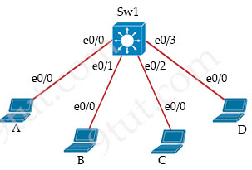
Host A switch interface is configured in VLAN 2. Host D sends a unicast packet destined for the IP address of host A.
Sw1#show mac-address table
Mac Address Table
-----------------------------
Vlan Mac Address Type Ports
---- ----------- ------- ----
2 000c.859c.bb7b DYNAMIC e0/1
3 000c.85dc.bb7b DYNAMIC e0/1
2 0010.11dc.3e91 DYNAMIC e0/2
3 0010.11dC.3e91 DYNAMIC e0/2
2 0044.42d9.c693 DYNAMIC e0/3
Sw1#
What does the switch do when it receives the frame from host D?
A. It floods the frame out of every port except the source port.
B. It shuts down the source port and places It in err-disable mode.
C. It drops the frame from the MAC table of the switch.
D. It creates a broadcast storm.

Answer: A
Explanation
HostA MAC address and port have not been learned in the switch MAC address table so the switch will flood the frame out of all ports except the source port where it received the frame.
Question 12.113
Which functionality is provided by the console connection on a Cisco WLC?
A. secure In-band connectivity for device administration
B. out-of-band management
C. HTTP-based GUI connectivity
D. unencrypted in-band connectivity for file transfers

Answer: B
Explanation
The console port is used for out-of-band management, system recovery, and early boot operations.
Question 12.114
Refer to the exhibit.
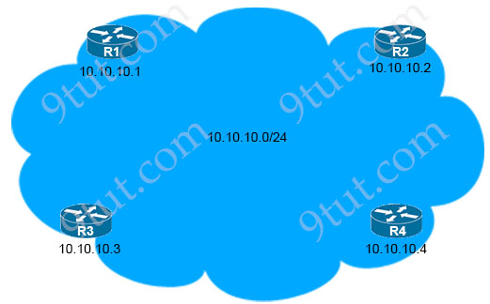
R1# show ip route
C 1.0.0.0/8 is directly connected, Loopback0
10.0.0.0/8 is variably subnetted, 4 subnets, 2 masks
O 10.10.10.3/32 [110/100] via 10.10.10.3, 00:39:08, Gigabitethernet0/3
C 10.10.10.0/24 is directly connected, Gigabitethernet0/0
O 10.10.10.2/32 [110/5] via 10.10.10.2, 00:39:08, Gigabitethernet0/2
R 10.10.10.4/32 [120/10] via 10.10.10.4, 00:39:08, Gigabitethernet0/4
Which next-hop IP address has the least desirable metric when sourced from R1?
A. 10.10.10.4
B. 10.10.10.2
C. 10.10.10.5
D. 10.10.10.3

Answer: D
Explanation
This question asks about “metric”, not Administrative Distance so we have to compare the second parameter in the square brackets. In this case “100” is the “least desirable metric” and it belongs to 10.10.10.3 (R3).

